Protocol for survey to determine direct and indirect costs due to TB and to estimate proportion of TB-affected households experiencing catastrophic costs

Field testing version

World Health Organization, Global TB Programme

Table of Contents

List of boxes, figures and tables 4

Glossary for terms used in this protocol 6

1. Background and rationale 8

2. Study objectives 9

2.1 Specific objectives 9

2.3 Potential policy implications 10

3. Methods 11

3.1 Development of the methodology 11

3.2 General methodological considerations for measuring percentage experiencing catastrophic cost 12

3.3 Overview of the study design 15

Basic design: Cross sectional survey with retrospective data collection and projections 15

Optional design: Longitudinal cohort design with repeat data collection for the same study subjects 18

3.4 Sampling strategy 20

3.5. Sample size calculation for a cluster sample survey 22

4. Planning and conducting the survey 27

4.1. Establish survey team and obtain additional technical assistance 27

Composition of survey team 28

Suggested qualifications for survey staff 31

4.2. Adapt generic survey instrument to local conditions and translate to local language 32

4.3 Ethics review 33

Information to be provided by investigators to the ethics committee include: 33

Information to the patient 34

Consent 34

Compensation 34

4.4. Train interviewers 35

Objective of the training: 35

Method 35

The deliverables of the training 35

4.5. Piloting 36

4.6. Collect data through the survey tool 37

Timing of interviews 37

Place of interviews within the facility 38

Time required for the interview 38

Role division 38

Translation for migrants 39

E-survey 39

4.7. Manage and enter the data 40

4.8. Analysis of patient costs 41

4.8.1 Introduction to the section 41

4.8.2 Key methodological challenges for the analysis of costs 43

4.8.3 Estimating costs during the TB episode 46

Time horizon for TB episode 46

Total costs of a TB episode 46

Calculating patient's time loss or cost of productivity loss 49

Coping costs 52

Guardian/companion costs 52

4.8.4. Estimating household annual income before the TB illness episode 52

4.8.5. Determining percentage of households experiencing economic burden or catastrophic costs. 53

Approach 1: calculate the total episode cost as percentage of annual household income before the TB episode. 53

Approach 2. Percentage of households experiencing “dissaving” 54

Longitudinal design 55

Non-response analysis 56

Assessment of differences between sub-populations 56

4.9 Implementation and dissemination plan 56

Plan for dissemination and publication of the project findings 56

Timeline for dissemination 56

4.11. Budget 59

References 61

Acknowledgements 63

Technical assistance 63

Task force members (including at WHO secretariat) 63

Annex 1 Analysis: basic result calculations (mock data) 65

Annex 2: Estimating income based on asset questions: A Practical Example in Ethiopia 67

Annex 3 Consent form 68

List of boxes, figures and tables

**Boxes**

**Box 1.** Catastrophic costs incurred by TB patient’s households: operational definition adopted by the Task force (March, 2015)

**Box 2.** Selecting clusters and individuals within each cluster

**Box 3.** Estimating indirect costs and valuing patient’s time: a methodological challenge

**Figures**

**Figure 1.** Patient incurred costs: current data availability

**Figure 2**. Sample size of past patient cost surveys.

**Figure 3**. Interview instrument parts.

**Figure 4.** Overview of the analytical approach with respect to data collection timing

**Figure 5**. Overview of the design for longitudinal study

**Figure 6**. Cluster random sampling. Required number of clusters and cluster size for different levels of assumed percentage of patients experiencing catastrophic cost, when the desired relative precision is 30%, cluster sampling is used with an assumed clustering effect of 0.4, and 85% participation rate.

**Figure 7.** Organogram for survey team (orange color means optional function)

**Figure 8a.** E-survey tool image

**Figure 8b.** E-survey tool image on android

**Tables**

**Table 1.** Required sample size (using same assumptions as for cluster- randomized sampling above) for different levels of desired precision

**Table 2.** Practical approach to time costs to use in this protocol

**Table 3.** Data availability in the survey to value patient’s time according to the method

**Table 4.** Suggested timeline for a country starting in 2015

**Table 5.** Example of budget template to establish budget for the patient cost survey

**Tables in Annex**

**Table.1.** Total Patient Cost of TB episode, Net of Reimbursements (2015 US$)

**Table. 2.** Catastrophic Cost Determination, Approach #1

**Table. 3.** Catastrophic Cost Determination, Approach #2

**Table. 4.** Non-Respondents Analysis

# Glossary for terms used in this protocol

**Catastrophic costs due to TB.** Two approaches – 1) The sum of a) *out-pocket payments* for TB diagnosis and treatment made by TB patients in a given household (direct medical payment) ; b) payments related to the use of TB health services, such as payments for transportation, accommodation or food (direct non-medical payment for TB treatment) *net of any reimbursements to the individual who made the payments* and c) income losses incurred by both the TB patient and any escort member *net of any welfare payment* (indirect net cost of seeking TB treatment) that exceeds a given threshold (e.g. 20%) of household’s income. 2)dissaving due to overall TB cost (i.e., direct medical, direct non-medical and opportunity cost) (Approach 2). Source: Working definition adopted by the Task force (March, 2015)

**Catastrophic health expenditure.** Out-of-pocket payments for health care (for all conditions), exceeding a given fraction of a household’s expenditure. The focus is on the burden of direct outlay of cash made by households to improve or restore the health of any of their members (WHO and World Bank, 2015).

**Direct costs:** Medical and non-medical out-of-pocket payments are direct costs.

**Food payment.** Out-of-pocket payments for food bought in relation to travelling to the health care visit, and during visit or hospitalization, patient and household member (e.g. if meals at the hospital are not provided). Food costs are part of direct non-medical costs.

**Household income (disposable):** revenues from household earnings net of taxes. It includes labour income as well as welfare payments. It does not include other types of income such as transfers, rental income, revenues from sales of assets etc. The rationale for selecting this measure of income is that the measure of household’s financial resources should be related to what is actually available to families to meet their economic needs.

**Income losses incurred by patients.** The calculation multiplies the total period of absence by the wage rate of the absent worker. Several options will be explored and analyzed on a sensitivity analysis e.g. self-reported wage, wage of an income quintile (determined by asset score), wage of the lowest paid unskilled government worker (Cameron, 2009 and WHO and HAI, 2009) and other wage measures.

**Indirect costs of seeking TB treatment.** Patients/ household lost time and lost wages (net of welfare payments) and income due to TB health care seeking and hospitalization, during the illness episode.

**NTP network.** Health facilities, public or private, treating and notifying TB in line with the guidelines of the national TB programme.

**Out-of-pocket payment for health care (medical)**. Direct payment made to health-care providers by individuals *at the time of service use*, i.e. excluding prepayment for health services – for example in the form of taxes or specific insurance premiums or contributions – and, where possible, net of any reimbursements to the individual who made the payments. OOP payment (including gratuities and payments in-kind) includes payment to formal medical professionals, informal traditional or alternative practitioners, clinics, health centres, pharmacies and hospitals for medical services and products such as consultations, diagnosis, treatment and medicine (WHO and World Bank, 2015).

**Out-of-pocket payment (in this protocol, i.e.) for TB care**. Out-pocket payments for TB treatment made by a diagnosed TB patient (e.g. consultation fee, drugs, diagnosis, hospitalization etc)

**Out-of-pocket payment non-medical**. Out-pocket payments made by patient or escort related to the use of TB health services, such as payments for transportation, accommodation, food etc.

**Out-of-pocket payment net/gross**. Total payment (medical and non-medical) minus any reimbursement received for payments made is a net payment.

**TB episode.** The period of time from self-reported onset of TB-related symptoms until end of treatment or death.

**Overall cost (of TB episode).** The sum of direct net total cost and indirect net cost

**Travel costs.** Total payments by the patient for travel to the facility. Travel costs are part of direct non-medical payments for f TB treatment.

**Welfare payments** Refers to paid sick leave, disability grant, cash transfer for poor families or other cash transfer.

# 1. Background and rationale

Tuberculosis (TB) patients often incur large costs related to illness, as well as to seeking and receiving health care. Such costs can create access and adherence barriers which can affect health outcomes and increase risk of transmission of disease. These costs can also contribute to the economic burden of households. In low- and middle-income countries, TB patients face costs that on average amount to half their annual income (Tanimura et al 2014). In all settings, TB affects the poorest segment of society the worst. The poverty-aggravating effects of TB are therefore gravest for those that are already most vulnerable.

While out-of-pocket medical expenditures are important, lost income is often the dominant contributor to economic hardship. Direct non-medical costs, such as costs for travel and food during health seeking are also significant given the often long health seeking period and the six months to two years period of treatment. (Tanimura et al 2014).

To overcome access and adherence barriers, as well as to minimize the economic burden for TB patients (and their households) it is therefore essential to address both direct and indirect costs. Interventions are needed to address high medical costs, as well as costs of food and transport, and lost earnings. Therefore, both health financing and delivery models, as well as social protection mechanisms (such as job protection, paid sick leave, social welfare payments, or other transfers in cash or kind) need to be considered (Mauch et al 2012, Lönnroth et al 2014).

One of the three targets for the End TB Strategy is that no TB patient or their household should face catastrophic costs due to TB, and this target should be achieved by 2020. This target is in line with policy efforts to move health systems closer to universal health coverage (UHC) because TB cannot be eliminated without addressing the barriers to uptake and completion of needed treatment, important aspects of service coverage. High cost faced by patients and their families is one important source of these barriers, acting as a deterrent to treatment or causing problems of financial protection for those who do pay. The share of the population incurring “catastrophic costs” (expenditures beyond a defined threshold of a household’s capacity to pay) is one measure of financial protection that is commonly used as an indicator of progress towards UHC (WHO and World Bank, 2015). The TB-specific indicator is different from the population-based indicator of catastrophic costs because it incorporates both direct medical payments for treatment, direct non-medical payments (such as transportation, lodging charges) and indirect costs, such as income losses. The TB-specific indicator is also restricted to a particular population: diagnosed TB patients treated in NTP networks. Furthermore, the objective of the TB-specific measure is to identify and reduce barriers to treatment adherence and not, strictly speaking, to measure financial protection (i.e. doing this at the level of an individual disease would not make sense as it would suggest a policy concern with impoverishment from one disease as compared to other diseases). Hence, due to differences in both the concept and the approach to measurement, the indicator of catastrophic TB cost is not comparable to the population-based indicator of catastrophic expenditures, and should not be used in relation to any other measure apart from “TB catastrophic costs” over time in the same country.

That being said, however, the relevance and importance of this work are clear: reducing these direct and indirect costs will contribute to improvements in treatment adherence and in financial protection. Thus, the planned work to assess the magnitude of patient costs and identify the main cost drivers, can be used to monitor financial barriers to adherence and inform related health and social policy changes to improve TB control. This broad perspective is essential because, given the nature of the TB treatment protocol, reforms to the health financing system alone are unlikely to be sufficient to enable the diagnosed TB-affected population to overcome fully the barriers to successful completion of treatment. Action on the demand-side is essential, such as e.g. extension of certain social protection mechanisms to ensure treatment success for people in the informal sector and the vulnerable population groups that comprise most of the TB affected population. Reforms to service delivery strategies are likely also needed in many settings to reduce direct and indirect costs associated with care-seeking. Another potential benefit of implementing this type of survey is that it can also inform the development of more in-depth operational research to investigate identified problems and to evaluate proposed solutions.

Countries are recommended to assess the composition and magnitude of these direct and indirect costs through periodic health facility-based surveys. This is complementary to other needed assessments of local and national TB epidemiology, health seeking, and health care and social service coverage and bottlenecks for TB patients. Such assessments are a fundamental part of the End TB Strategy, which stresses the need for national adaptation based on the local epidemiological and health systems situation.

This protocol provides guidance on how to conduct a facility-based survey to assess the economic burden (i.e. direct and indirect costs) incurred by TB patients (and their households) and to identify cost drivers in order to guide policies on cost mitigation and delivery model improvements. The protocol also provides guidance on how to measure the proportion of TB patients (and their households) experiencing catastrophic cost, and can thus be used to determine baseline and periodically measure progress towards the End TB Strategy target.

The document outlines a standardized methodology. Nonetheless, the protocol and the related survey instrument need to be adapted to the country setting. There are several methodological challenges, which are outlined in the protocol. The current version of the generic protocol is intended for field testing and for validation of proposed approaches. It includes a number of design options. After a field testing period, which is anticipated to last during 2015 and 2016, the protocol will be revised and simplified further. In the final version there will be fewer options and less need for country adaptation. Similarly, the generic questionnaire instrument will be shortened and simplified after the field testing.

# 2. Study objectives

## 2.1 Specific objectives

1. To document the magnitude and main drivers of patient costs in order to guide policies on cost mitigation for the purpose of reducing financial barriers to adherence. This is in line with the End TB Strategy and its 2020 target that no household affected by TB should incur catastrophic costs.
2. To determine baseline and periodically measure the percentage of diagnosed TB patients treated in the NTP network (and their households) in the country who incur direct and indirect costs beyond a a defined threshold of their annual income.
3. To determine the correlation between facing costs above different thresholds of annual household income and dissaving, in order to assess if the measure of dissaving is a sufficient metric of catastrophic costs (for field testing period to inform selection of proxy for final protocol)
4. To help design a standardized approach for periodic measurements of financial barriers to adherence based on baseline experience and to enable reporting on the 2020 End TB Strategy target that no family affected by TB will incur direct and indirect catastrophic costs as specifically defined in the context of this work.

## 2.3 Potential policy implications

For TB programmes and other departments within the Ministry of Health, implementation partners, Ministry of Social Welfare (or equivalent) and other relevant stakeholders, analysis should help inform:

1. Design policies and interventions to minimize barriers for accessing and adhering to TB care and mitigate the economic impact of diagnosed TB for patients and their families;
2. Design of research that might be needed, and/or to further examine the determinants of cost barriers in the diagnosed TB patient population, and/or to assess the effectiveness of policies and interventions to mitigate these costs.

# 3. Methods

## 3.1 Development of the methodology

The WHO Global TB Programme (GTB) convened a task force on catastrophic cost measurement in March 2015. Before the task force meeting GTB had developed a first draft of the protocol and instrument, building on the extensive previous work that has been done to measure costs for TB patients and affected households, notably the patient cost tool (TBCTA 2011) and its adaptation for MDR-TB patients (TBCTA, 2014).

Previous experiences include 46 surveys that included direct and indirect TB patient cost data (Tanimura 2014, Foster, 2015). Most of the studies focused on determining the main cost drivers in order to inform policy on efforts to reduce costs for patients. Twelve studies calculated costs as a percentage of household income. However, only one study reported the percentage experiencing catastrophic costs, and it did so using a data driven cut-off of >20% of annual household income. The same study assessed the association between adverse TB outcomes and occurrence of catastrophic costs (Wingfield, 2014). Other studies of cost in relation to income reported only mean and/or median values and ranges for the whole study population or for subgroups. As shown in fig. 1 only two countries have published data on costs as a percentage of household income after 2010: Peru and South Africa. Before 2010, 9 countries (India, Ghana, Viet Nam, Dominican Republic, China, Peru, Bangladesh, Thailand, India and Brazil) analysed costs as a percentage of household income. Figure 2 shows the sample sizes used is selected studies.

Figure 1: Patient incurred costs: current data availability

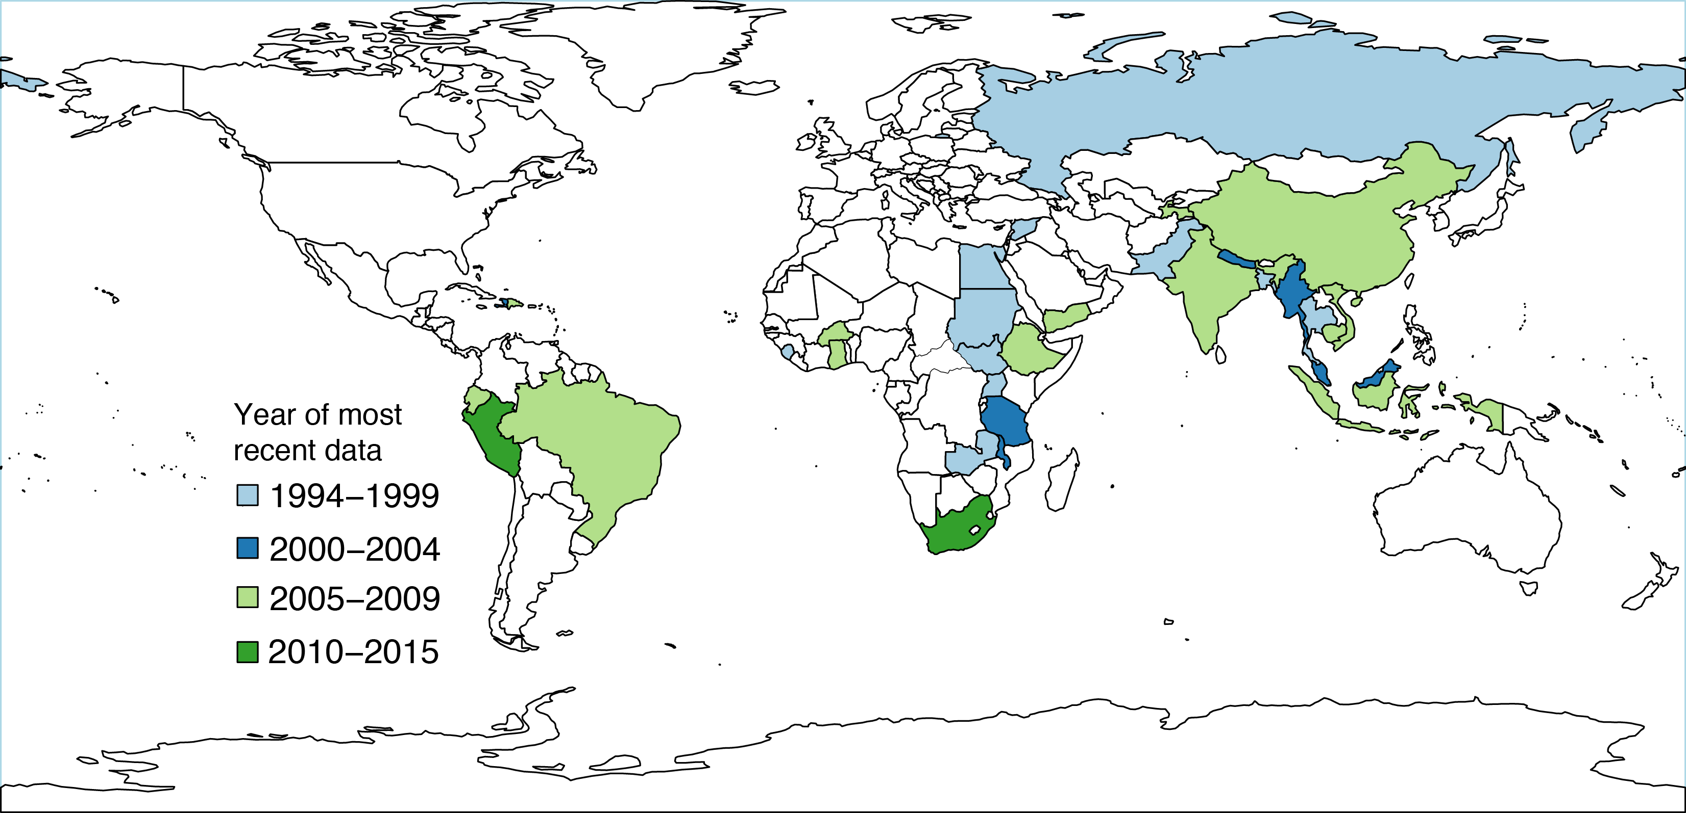

*Source: WHO/GTB compilation based on Tanimura et al, 2014, Foster et al, 2015 and Wingfield T et al, 2014.*

Figure 2. Sample size of most recent TB patient cost surveys. (Country name followed by cost year not publication year)

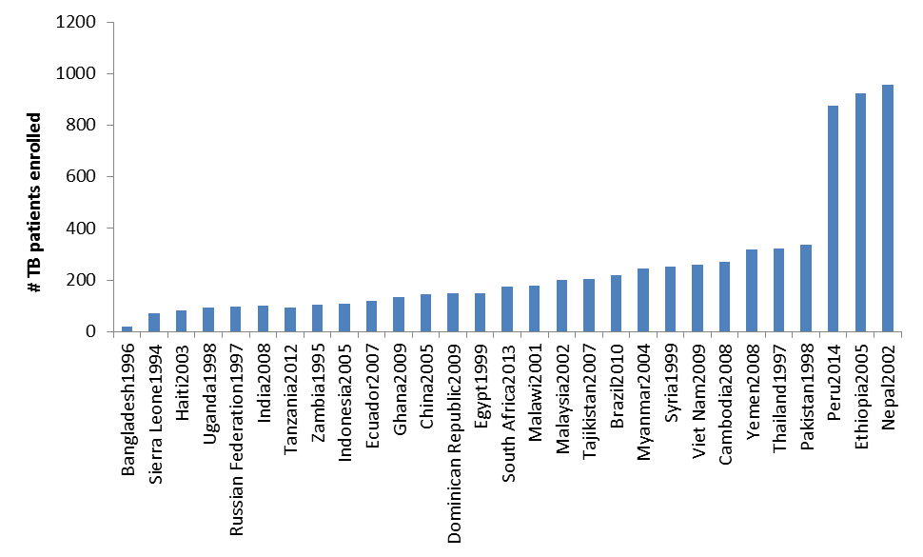*Source: WHO/GTB compilation based on Tanimura et al, 2014, Laurence Y, forthcoming. Note that larger sample size exist in countries from earlier surveys and cost years. E.g. India 2007(# 896), India 2005 (# 1050), South Africa 2010 (# 1999), South Africa 2001 (# 1182), Brazil 2008 (# 218).*

There is thus a rich literature on magnitude and types of costs faced by TB patients and their households. However, the task force members -- most of whom were involved in one or several of the previous studies -- acknowledged that much of the data are outdated, diverse methodology has been used and there is a need to further standardize general data collection approaches as well as the measurement of the catastrophic cost indicator.

The task force reviewed and provided feedback on the initial draft. Thereafter the protocol and instrument have undergone several revisions and inputs have been received from additional experts. It has been presented to a PAHO/World Bank meeting in May 2015. The instrument has been piloted tested on a limited scale in Kenya in April 2015, and country adaptation has been tried out for one country (Myanmar) in June 2015.

## 3.2 General methodological considerations for measuring percentage experiencing catastrophic cost

The task force proposed two provisional approaches to measure the percentage of TB-affected households facing catastrophic costs. This field-testing version of the protocol includes both options with the aim to further validate and elaborate the definition and measurement approach.

The first approach calculates the percentage of TB-affected patients (and their households) that face costs (medical, non-medical expenditures as well as income loss net of transfers and reimbursements) that are above a certain percentage of annual household income. The taskforce suggested to tentatively use 20% as threshold in this analysis, since this level has been associated with poor clinical TB outcomes (Wingfield et al 2014). Other data-driven cut-offs may be tested, depending on association with clinical outcomes, with dissaving strategies or other measures of impoverishment.

**Box 1: Catastrophic costs incurred by TB patient’s households: operational definition adopted by the Task force (March, 2015)**

|  |
| --- |
| The end-TB indicator refers to the “percentage of TB patients treated within the NTP network (and their households) facing catastrophic costs (indirect and direct)”.  Catastrophic costs due to TB are defined as total costs (indirect and direct combined) exceeding a given threshold (e.g. 20%) of the household’s income.  The total indirect and direct costs of TB are defined as the sum of;  a) out-pocket payments for TB diagnosis and treatment made by TB patient’s households (direct net medical payment for TB treatment denoted ;  b) payments related to the use of TB health services, such as payments for transportation, accommodation or food (non-medical out-of-pocket payments for TB treatment denoted ) net of any reimbursements to the individual who made the payments and  c) income losses incurred by both the TB patient and any escort member net of any welfare payment (indirect net cost of seeking TB treatment denoted )  The proportion with total costs exceeding a given threshold (e.g. 20% denoted ) of household’s annual income , is calculated as:  will be calculated for the patient interviewed at the health facility. If more than one household member is registered for treatment, costs for all patients within a household will be collected (if possible logistically) or estimated.  Household’s disposable annual income , is defined explicitly.  , the population of interest are patients treated in NTP network  Sample estimate is done using patients as the unit of analysis. However economic consequences in the context of the household of the patient will be analysed. No additional layer of cluster sampling will be introduced to estimate how many families/households the interviewed and the national notifications (not possible without an electronic case-based registry) represent but the analysis will bear in mind the number of patients sampled that belong to the same household. |

The second approach calculates the percentage of households experiencing “dissaving” (such as taking a loan or selling property or livestock). This proxy indicator by definition indicates financial weakening of a household. Occurrence of dissaving has been associated with total household costs of TB (Madan et al 2015). However, further work is needed to assess the correlation between high total cost due to TB illness in relation to income and seemingly irreversible coping strategies. The present study protocol will contribute to the development of this proxy indicator. As evidence of the correlation between dissaving and catastrophic costs increases, the task force will use the evidence to adapt the operational measure of catastrophic costs. Collecting and analyzing data for this indicator is probably less methodologically challenging than collecting data for the first approach.

A patient survey at the health facility level has been identified as the most appropriate data collection approach. In national household surveys, when incorporating a health expenditure module, it is not possible in general to attribute health spending to any specific disease. The sample size required for population-based surveys to identify a sufficiently large sample of persons with TB is very large. Moreover, only self-reported TB can be used as criteria for inclusion, which introduces a large risk of bias. Finally, these surveys do not normally incorporate non-medical expenditures or indirect cost related to health episodes. It is therefore not feasible to use such platforms to determine costs for people with TB.

For practical reasons, it is proposed in this protocol that the study population should be restricted to persons who have started TB treatment in a health facility that delivers TB care in line with the national TB programme (NTP) guidelines, and registers and records the treatment in standard TB treatment cards and registers. This means that costs for persons treated “outside the NTP”, e.g. in private and public clinics not linked to the NTP will not be captured. Moreover, costs for persons who do not access healthcare and are never diagnosed and treated for TB will not be considered. In this protocol the term “NTP network” will be used as shorthand for those health facilities treating and notifying TB in line with NTP guidelines, which may also include private and NGO facilities collaborating with NTP. Therefore, the operational definition of the catastrophic cost indicator is “percentage of diagnosed TB patients treated within the NTP network (and their households) facing (direct and indirect) catastrophic costs”.

In the case of countries where significant proportions of patients seek care outside the NTP network, separate surveys may be conducted to capture costs in the private sector outside the NTP network if feasible, to better understand the drivers of such costs. However such data will not be appropriate for comparisons across countries and should not be included in the national estimate of catastrophic costs due to TB. Moreover, separate surveys may be conducted to capture costs among prevalent TB cases in the community (e.g. through the inclusion of cost questions in a TB prevalence survey instrument). However, such data should not contribute to the national estimate of proportion facing catastrophic costs, in order to ensure standardized measurement with comparability over time and across countries.

It should be noted that the operational definition of the catastrophic cost indicator differs in essence from one of the well-established approach used to measure the lack of financial protection at the country level, namely the indicator of catastrophic health *expenditure*. WHO defines the incidence of catastrophic health expenditure as the share of the *population* spending more than 40% of their non-subsistence spending on OOP payments (Saksena, 2014). OOP payment is defined exclusively in relation to direct medical payments made to health providers at time of use net of any reimbursement received and includes payments for all household’s members (WHO and World Bank, 2015). It is a measure of the performance of the health financing system, at the overall population level. The indicator of catastrophic *costs* incurred by households *affected by TB*, refer instead to the total economic burden (direct and indirect costs combined), related to one diagnosed health condition only, treated in a particular type of setting, in relation to total household income. The two indicators are therefore not comparable.

## Overview of the study design

## Basic design: Cross sectional survey with retrospective data collection and projections

In the basic cross sectional design all consecutive TB and MDR-TB patients registered for treatment who are attending a sampled facility for a follow up visit (after a minimum of 2 weeks into the present intensive or continuation treatment phase) should be invited to the survey.

Each patient should be interviewed only once and will report on expenditures retrospectively. When this design is used, some patients will be interviewed in the intensive treatment phase and others in the continuation treatment phase, with expenditure and time loss data collected for that particular phase only. Moreover, within these two categories, patients will be interviewed at different time points during their treatment. Data collection for patients in different treatment phases will allow the collection of data that can be used to impute data and model projections of future and past costs during the entire illness episode (Figure 4).

This approach will simplify sampling and make data collection efficient since most patients attending the facility during the study period will be eligible to be invited to the survey. Since no follow-up interview is required, such a study can be completed within 2-3 months in countries with moderate to high TB incidence.

The survey instrument has five parts (Figure 3):

1. Patient information to be obtained from TB treatment card before interview (for all patients)
2. Informed consent, inclusion/exclusion criteria, and checklist for which parts of the questionnaire to fill for different patients treated under different TB treatment categories and phases (for all patients)
3. Overview of TB treatments before current treatment, up to 2 years before the current treatment started (for re-treatment cases only)
4. Costs before the current TB treatment (for new cases interviewed in the intensive phase only)
5. Cost during current TB/MDR-TB treatment (for all patients)



Figure 3. Interview instrument parts.

Information from the TB treatment card (Part I), informed consent (Part II), and information about costs related to the current TB treatment (Part V), should be collected for all patients.

Information about costs related to health seeking and diagnostic procedures before the person was registered as a TB patients within the NTP network (Part IV) should be collected only for new patients (either on 1st line treatment or on MDR treatment) who are interviewed in the intensive phase. For new patients who are interviewed in the continuation phase, information should be collected only about costs related to the continuation phase (with a few exceptions, such as hospitalization cost and coping costs, which should also be collected for the intensive phase for these patients). This is because of the considerable challenge for patients to remember events and costs incurred many months prior to the time of the interview.

For the same reason, no detailed information should be collected about costs related to health seeking and diagnostic procedures before the person was registered as a TB patients within the NTP network for previously treated cases (either on 1st line treatment or on MDR treatment), regardless of which treatment phase the patient is in at the time of the interview. Instead, all previously treated cases will be asked brief summary questions about the number of previous TB treatments, the start year and duration of previous TB treatments, number of hospitalization episodes and their duration during previous TB treatments (part III). This will be collected for previous treatment up to 2 years before the start of the present treatment episode.

Information collected in part IV for new cases interviewed in the intensive phase will be used to impute data and model costs for patients interviewed in the continuation phase and for re-treatment cases. Similarly, information about costs in the continuation phase collected from patient interviewed in this phase will be used to project costs for patients interviewed in the intensive phase (figure 4).

Figure 4. Overview of the analytical approach with respect to data collection timing (Basic design: Cross sectional survey with retrospective data collection and projections). *Blue dot signals interview moment. Lighter shades of green and red, mean extrapolation of past costs into the future. Yellow means costs are estimated based on some answers and other patient’s data. Grey means not applicable.*

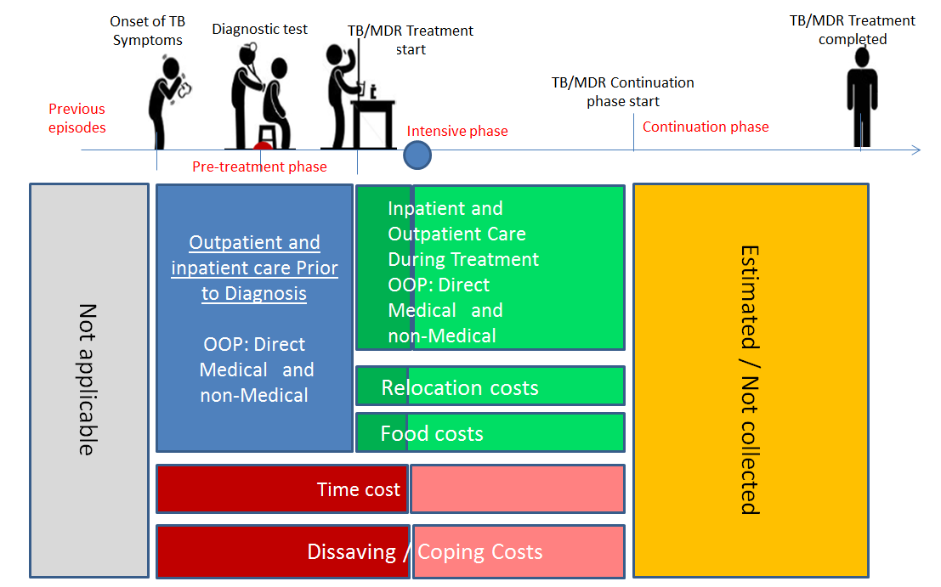

New cases

(first line or MDR-TB treatment)   
 Interviewed in intensive phase

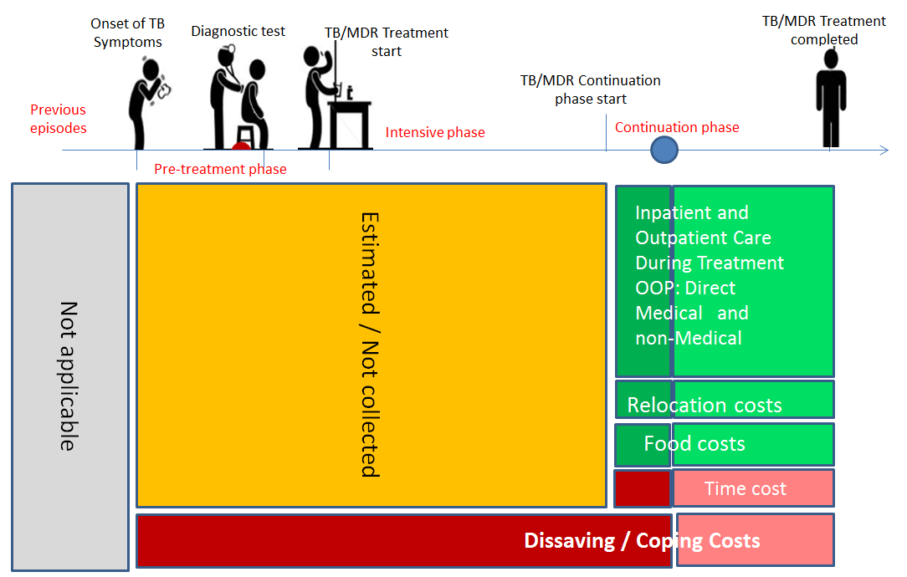

New cases

(first line or MDR-TB treatment)   
 Interviewed in continuation phase

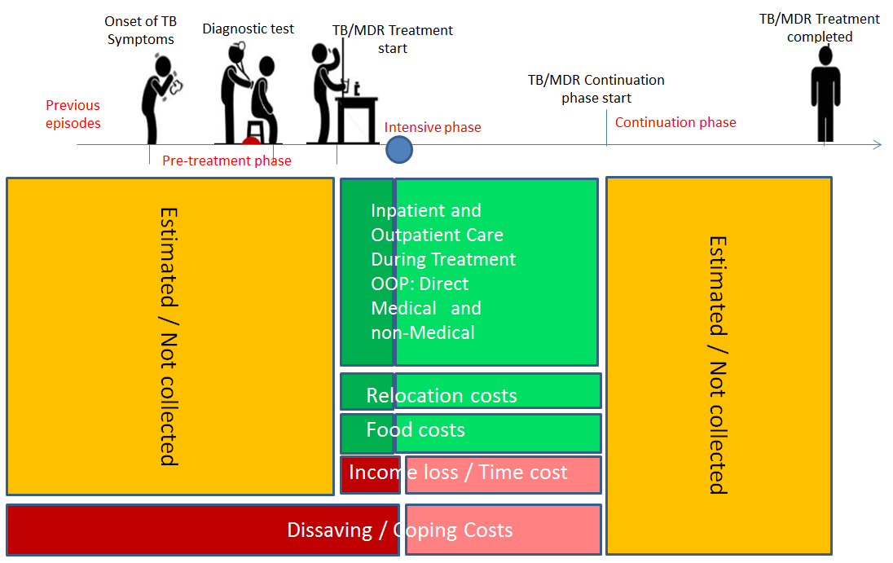

Previously treated cases

(first line or MDR-TB treatment)   
 Interviewed in intensive phase

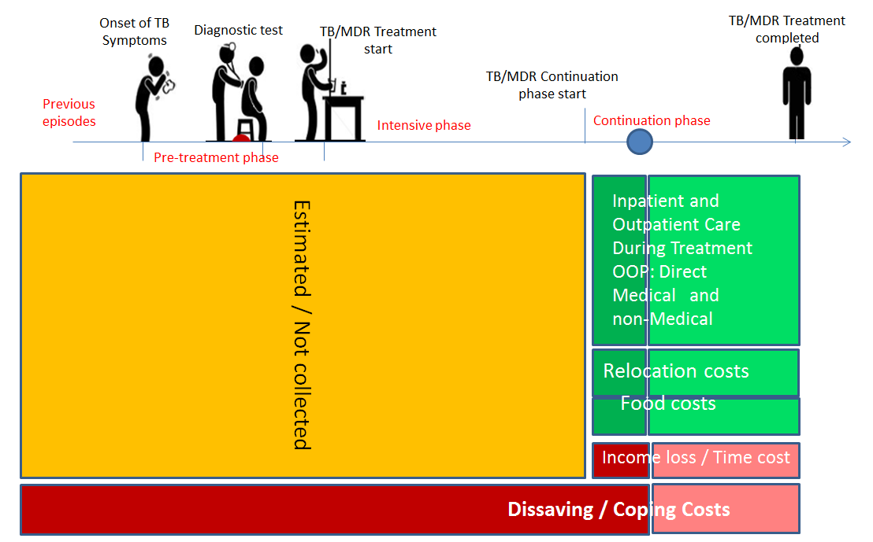

Previously treated cases

(first line or MDR-TB treatment)   
 Interviewed in continuation phase

## Optional design: Longitudinal cohort design with repeat data collection for the same study subjects

While the basic design has the advantage that it simplifies data collection and the study can be completed quickly, the disadvantage is that both forward and backward projections are required in order to model cost during the entire illness episode. This introduces additional uncertainties. A longitudinal design can overcome this challenge, but requires repeat interviews, a slower enrollment process (the only eligible participants are those who are just starting their treatment), longer time to complete the study (especially for MDR-TB patients), and a more elaborate and expensive plan and infrastructure to enable identification of the survey participants for a repeat interview, including a method for tracking patients who transfer out or are lost to follow-up. The standard TB treatment register and modalities for cohort analysis can be used as a platform for this purpose. An additional advantage of this design is that it can capture information about patients who do not start treatment (after TB diagnosis) and patients interrupting treatment, which can be correlated to information about previous costs.

The ideal longitudinal design involves (figure 3):

1. A first interview at the time of TB treatment initiation (alternatively after TB diagnosis).
2. Interview instrument part III for previously treated cases
3. Interview instrument part IV for new cases
4. A second interview at the end of the intensive treatment phase, with interview instrument part V
5. A final interview at the end of treatment, again with interview instrument part V

Figure 5. Overview of design for longitudinal study

***New cases***

Interview 3:

End of treatment

Interview 2:

End of intensive phase

Interview 1:

TB diagnosis

Part V, continuation phase

Part V, intensive phase

Part IV

***Previously treated cases***

*Extrapolated from new cases*

Interview 3:

End of treatment

Interview 2:

End of intensive phase

Interview 1:

TB diagnosis

Part IV

Part III

Part V, continuation phase

Part V, intensive phase

The cross section and longitudinal design can be combined. For example, a longitudinal design can be used for a sub-sample of patients, which can be used to validate the analytical approach based on modeled projections.

## 3.4 Sampling strategy

**Study population**

The study population includes all patients (including children) who are on TB or MDR treatment (in continuation or intensive phase) within the NTP network (public and private facilities). This means that sampling from the study population will be done in health facilities belonging to the NTP network.

This protocol excludes people who are treated in facilities that are unlinked to NTP (i.e. private facilities that are not formal part of a PPM initiative). It also excludes people who have not been put on TB treatment. Findings can therefore only be extrapolated to the subset of TB patient who receive care under NTP network and their household, and conclusions cannot be drawn about all people with TB in the country. While this is a limitation, it is the only feasible way to establish a sampling frame for the study. In addition, the impact of TB costs are analysed on the household level so if more than one household member is registered for treatment, costs for all the patients within a household will be collected (if possible logistically) or estimated. Interpretations of study findings need to be done accordingly.

**Sampling strategy options**

A national *simple random sample of TB patients* on treatment is theoretically possible to draw in countries that have electronic registers with real time surveillance information that can be used as sampling frame. Few countries have such a register. Moreover, this sampling strategy has not been reported in previous TB patient cost surveys and its feasibility is thus untested. This approach is not further discussed in this document. However, since it is a theoretically attractive approach, countries with the right conditions are encouraged to explore this strategy in consultation with a statistician or survey design specialist.

In most settings it is appropriate to use *cluster sampling*, which means that health facilities are sampled. All TB patients found in the district TB register and attending sampled facilities during the study period are eligible for inclusion in the study, and all included patients attending one sampled facility become a cluster. An advantage of using cluster sampling is that patient recruitment and data collection generally is easier from the logistics and financial point of view than when simple random sampling is used. A disadvantage is that sample size need to be increased, as compared to simple random sampling due to clustering effects (since people within clusters may be more similar to each other than to the rest of the TB patients in the country).

In order to ensure national representativeness, the standard recommended approach is to use *random* *cluster sampling*. In random cluster sampling, facilities are randomly selected from a sampling frame of health facilities in the NTP network. The efficiency of random cluster sampling can be enhanced by stratification (see below).

If random cluster sampling is not feasible, *purposive* *cluster sampling* may be considered. In purposive cluster sampling, facilities are purposively (non-randomly) selected from the same sampling frame based on set criteria for creating good representation of different types of facilities, different geographical areas, etc. While purposive sampling may improve feasibility in some situations, the principal problem is that is violates one of the underlying assumptions for the sample size calculations and standard statistical analysis and inference described below, namely that the selection of clusters is random. Therefore, efforts should always be made to use random sampling. Purposive sampling is appropriate if there is a specific objective to determine costs in a specific facility or geographical area.

A special situation is when the survey is integrated into another facility-based patient survey, cohort, or trial in the country. If that type of survey platforms is based on a random sample of facilities, it is equivalent to a random cluster design. If, on the other hand, the study is done in purposively selected facilities, the same limitation apply as for other types of purposive sampling, as described above.

**Steps for cluster sampling**

***Sampling of clusters***

The cluster sampling frame is a list of facilities treating TB within the NTP network, from which study facilities should be selected. Such list of facilities in normally available within NTP on national, provincial and/or district level.

A simple random sample of facilities may be drawn from a national level list. However, it is normally advisable to do the cluster sampling in a step-wise manner, from sampling of geographical units, to sampling of facilities within the geographical units. Primary units can be provinces or equivalent administrative level. Secondary units are usually districts or the NTPs basic management units (BMU). There may be one or several relevant TB facilities within a sampled BMU. The number of BMUs to sample in each geographical area should be proportional to number of TB patients registered in the BMU, e.g. in the previous years. In a random cluster sample design, both primary and secondary units are sampled randomly in a step-wise manner.

The step-wise approach can be combined with a stratified design in order to increase the precision and representativeness of the sample. In addition, the approach of stratification allows the estimation of stratum-specific estimates of catastrophic costs in TB, but their precision is lower compared to the overall nationwide estimate. For example, stratification can be done for urban and rural facilities is: if 25% of TB notifications are in urban areas and 75% in rural areas, then the survey should allocate about 25% of facilities (clusters) enrolment in urban areas and 75% in rural areas. Other stratification criteria for selection of geographical areas or facilities may include: poor vs. less poor provinces; hospitals vs. primary care facilities; public vs. private/NGO providers in the NTP network; facilities treating MDR-TB, etc.

***Sampling of TB patients***

Within sampled facilities, consecutive patients on TB treatment visiting the facility are eligible for inclusion. Inclusion of consecutive patients attending the facility can be considered equivalent to random sampling, provided that no additional inclusion criteria are introduced (e.g. attending at certain times of the day only). The TB register of the facility (hospital or ambulatory care) can be used as entry-point for the sampling of patients at facility level.

All consenting patients on treatment for TB or MDR-TB are eligible for the patient survey. (If the patient has not been treated for a minimum of 2 weeks of the current treatment phase the interview should be postponed until this time).

If the number of facilities selected from each area is proportional to number of registered TB patients in each area, the same patient sample size should be used within each sampled facility, regardless of catchment population and patient load. If not, the number of patients to be sampled should instead be proportional to the number of registered TB patients in the facility.

Stratified sampling of patients within facilities can also be considered, by defining quota for inclusion corresponding to patient characteristics in the country, e.g. by: patients on first line or MDR TB treatment; new or previously treated cases; children/adults, etc. However, stratified sampling of patients within facilities is logistically more challenging than stratified sampling of facilities, since the former requires careful monitoring of inclusion and measures to over- or under-sample certain sub-groups of patients.

Once the sample size for a facility has been determined, and any stratified sample size, consecutive patients attending the facility should be invited to the survey until the required sample size is achieved. In practice this can be done by assessing for each patient returning for a follow up visit, DOT, or picking up drugs.

## 3.5. Sample size calculation for a cluster sample survey

It is advisable to consult a biostatistician for the calculation of sample size. A number of assumptions need to be made for the sample size calculation. It is advisable to do a small pilot phase to confirm assumptions before establishing the final sample size for the study. Please note that while sample estimate is done using patients as the unit of analysis, the economic consequences are analysed in the context of the household of the patient. No additional layer of cluster sampling will be introduced to estimate how many families/households the interviewed and the national notifications (not possible without an electronic case-based registry) represent but the analysis will bear in mind the number of patients sampled that belong to the same household.

**Sample size required in a regular cluster sample survey**

**Step 1**. Hypothesize/guess the true proportion of households experiencing catastrophic costs due to TB illness (πg). To inform this, here are some suggestions of data sources;

* Data from any previous TB patient cost survey
* Data from TB patient cost surveys in similar countries
* Recent household expenditure surveys may include a health module that disaggregates the main cause of disease although answers might be regrouped as “infectious” and not TB specifically. It should also be noted that this data captures direct medical costs only and excludes non-medical and time loss value.

**Step 2.** Decide the relative precision around the estimate drawn from the survey (d). It is recommended that the relative precision is between 20% and 40%. This precision refers to the relative width of the 95% confidence interval. For example, if the assumed proportion experiencing catastrophic cost is 30%, then a relative precision of 20% means a 95% confidence interval ranging from 24% to 36%.

**Step 3.** Estimate the magnitude of the "design effect" (DEFF) related to cluster sampling. Since clustered-sampled (CS) surveys have larger statistical uncertainty compared to simple-random sampled (SRS) ones (for given assumptions) sample size needs to be increased for CS surveys (by multiplying sample size for SRS by a factor called the "design effect").

Sample size is then calculated with the following formula:

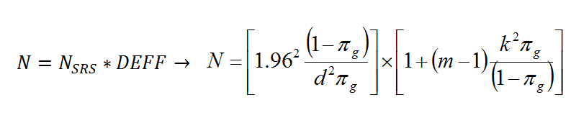

|  |  |
| --- | --- |
|  | Number of people included in the patient survey |
| *N*SRS | Simple Random Sampling size |
|  | “Prior guess” of the true proportion of families experiencing catastrophic costs due to TB illness (expressed as a proportion) |
|  | Relative precision (expressed as a proportion). Recommended 0.20 or 0.25 |
|  | Cluster size (=number of targeted individuals), assumed to be constant across clusters |
|  | Coefficient of between-cluster variation. Recommended to assume is in the range 0.4 – 0.6 |

**Step 4.** When the sample represents a large proportion of the study population of interest (all TB patients treated in the entire NTP network in a year) is large (5% or more), the sample size must be corrected using a "finite population correction" to account for the added precision gained by sampling a larger percentage of the population:

Where NFPC is the finite population corrected sample size, N is the original sample size, and T the size of the sampling frame of TB cases notified nationally per year. The effect of the finite population correction is that the required sample size diminishes the closer the sample size N is to the population size T. If the original sample size is calculated to 500 cases in a country that has 3,000 TB notifications, the finite population corrected sample size is 428.

**Step 5.** Calculated sample size can be increased to allow for non-participation in the survey. Estimate the participation rate (i.e. guess sample size for non-participants): assume for instance 90% participation. New sample size = (sample size)/0.9. However, in practice a target sample size for included patients, rather than invited patients can be set at the facility level, with instruction to continue sampling until the number has been achieved. In this case, the assumed participation is 100%.

Figure 6 shows an example of sample size calculation (required number of clusters and cluster size) for different levels of assumed percentage of patients experiencing catastrophic cost, when the desired relative precision is 30%, and cluster sampling is used with an assumed clustering effect of 0.4, and 85% participation rate, without finite population correction.

An Excel book is available (sample.size.xlsx) to calculate sample size and number of clusters based on your assumptions on the various ingredients.

Figure 6. Required number of clusters and cluster size for different levels of assumed percentage of patients experiencing catastrophic cost, when the desired relative precision is 30%, cluster sampling is used with an assumed clustering effect of 0.4, and 85% participation rate.

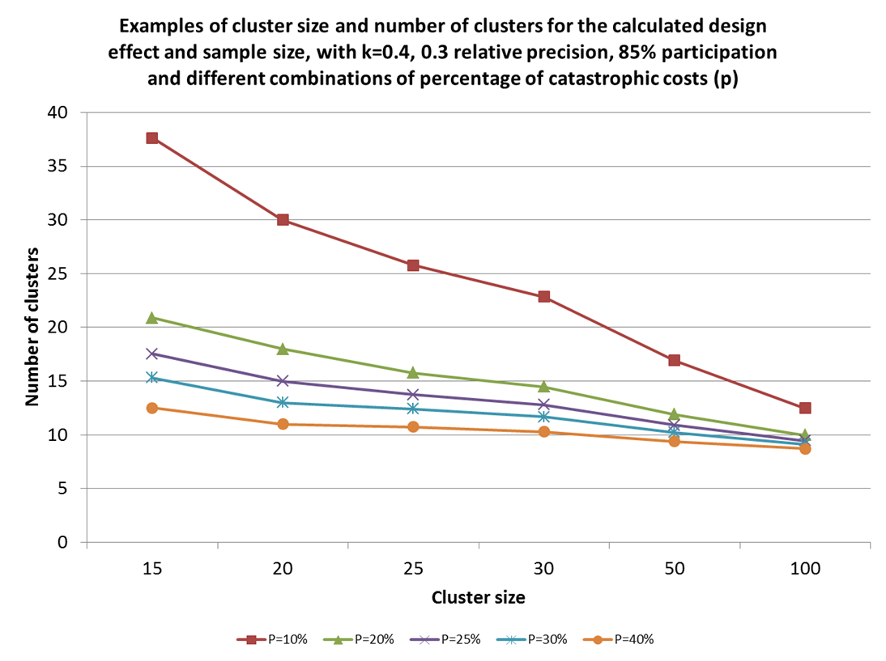

**Box 2: Selecting clusters and individuals within each cluster**

|  |
| --- |
| ***Example.* A sample size of 423 of TB patients (new or prev. treated) has been calculated after taking into account the effect of cluster sampling and a fixed cluster sample size of 15. The following steps must be taken:**    ***a*. Establish a list of the health centers with their annual number of patients (see table below).**    ***b*. Calculate the cumulative number of patients and record them in an additional column. Cumulative number for second center will be (number in first center) + (number in second center). Cumulative number for third center will be (cumulative number for second center) + (number in third center), and so on. The total number of patients treated in the country is 4000.**  ***c*. Determine the sampling interval: 4000/28 = 143.**  ***d*. Select a number between 0 and 143 at random (using a table of random numbers or the last digits of a currency note, for example). In this case, the number selected is 120.**  ***e*. The first cluster is selected using 120: it will be in the center n°8 because 120 falls between 0 and 123 (number of patients in center n°8).**  ***f*. Selection of the next clusters is done by adding the sampling interval 143 each time to this first number 120. The next number (120 + 143) = 263 falls in health facility 12 (cumulative number of patients for second center/cluster); the second cluster is therefore selected in center 12. The third number (263 + 143) = 406 also falls in health facility 12; the third cluster is therefore also selected in the center n°12.** |

#### 

#### Sample size required to prove that the percentage experiencing catastrophic cost is 0%, using Lot Quality Assurance Sampling

In a situation in which the percentage of patients experiencing catastrophic costs is assumed to be zero, or close to zero (such as in countries with high financial risk protection through universal health coverage and good social protection coverage), the sample size calculation can be based on an allowable upper limit error for 0% catastrophic cost. Table 1 shows the required sample size (using similar assumptions as for random cluster sampling above) for different levels of desired precision. For example, if 200 randomly selected patients are interviewed and none have experienced catastrophic costs, we can judge with 95% certainty that the true proportion in the country is somewhere between 0% and 1.8%.

Table 1. Required sample size (using same assumptions as for cluster- randomized sampling above) for different levels of desired precision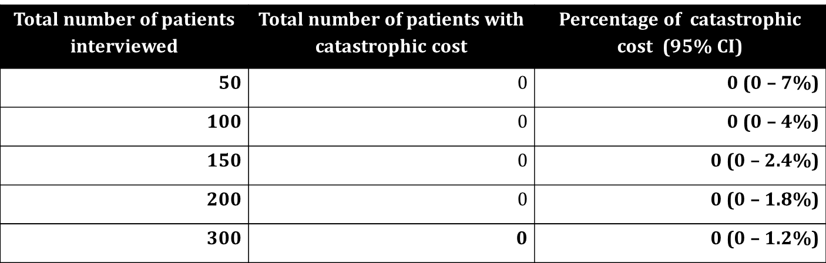

# 4. Planning and conducting the survey

The protocol is structured around the following steps required to implement the survey:

1. Establish survey team and obtain additional technical assistance
2. Adapt generic survey instrument and protocol to local conditions
3. Ethics review
4. Train interviewers
5. Pre-test (and then reiterate step 2-4 if necessary)
6. Collect data using the survey instrument
7. Manage the data
8. Analyze
9. Disseminate results
10. Budget for the study

## 4.1. Establish survey team and obtain additional technical assistance

The survey should determine the proportion of TB-affected households that experience catastrophic costs in the country. A national approach is therefore required to adapt this generic protocol and the generic survey instrument to national situation, and to establish an appropriate approach to obtain a nationally representative sample.

It is appropriate that the NTP takes the lead in establishing a survey team. However, a dialogue with national and international partners engaged in TB programme implementation and research is important. Moreover, it is advisable to consult with or contract academic institutions with experience in conducting patient surveys, for example those conducting epidemiological, social science or health economics research. A statistician may also be valuable, to assist sample size calculations and data analysis, and, if resources permit, an IT expert can help to adapt to e-survey tools. Alternatively WHO/GTB may also be available to provide some support remotely if the e-survey is used.

### Composition of survey team

The following functions should ideally be covered by the survey team (figure 4).

**Principal investigator (PI)**

Responsible for designing the study, ethical clearance, maintaining the quality of the study’s conduct and writing the final study report

Acts as liaison for communication outside the survey, in particular with NTP, public health service, local research institution and possibly the funding agency (securing funds for the survey)

If necessary the PI will appoint and supervise the work of a data analyst and a data manager

Tasks:

Validate the Protocol for survey to estimate proportion of TB-patients experiencing catastrophic costs

Ensure that survey implementation and analysis are conducted according to the protocol and the plan

Discuss any problems encountered during the survey, propose and decide the solution

Validate the survey results

**Survey coordinator**

Appointed by and reporting to the principal investigator

Responsible for the day-to-day management of the survey

Actively involved in the design of the study

Prepares training manual and study materials

Trains team leaders and interviewers

Supervises the work of data collection by team leaders through periodic reports

Assesses reports from team leaders and data manager

Tasks:

Coordinates overall implementation of survey to estimate proportion of TB-patients experiencing catastrophic costs

Plan the field implementation and training needed

Organize the writing of SOP (if required)

Together with the PI, contact and coordinate with local authorities

Ensure the quality assurance for all processes is implemented according to the protocol

Supervise the health facility implementation

Oversees the provision of supplies and required materials

Supervises the cash flow, fund distribution and their accountability

Leads the analysis of results

Organizes the writing of activity reports and final report

Plans the detailed budget of the survey

Provide any logistic support for the survey team

**Data analyst:** Responsible for data analysis throughout the survey and periodic data cleaning. This function is optional. Data analysis may be done by the PI if he/she is a health economist, economist or statistician with experience in these surveys.

**Data manager:**

Coordinates data management activities for the survey: receiving, batching, cleaning, merging data from different sources

Is responsible for the validation of double-entered data files

ensure that data are properly stored and backed up

check validated data files regularly for systematic errors (cleaning)

Develops data entry software and tools, effective and feasible to support the survey

Prepares database to be ready for analysis and data entry screens

Contributes in the analysis of results

Is responsible for completion of regular data management reports

Liaises with the survey coordinator on a regular basis

Reports without delay any problems encountered in data management.

**Team leaders**

Responsible for the organization and proper implementation of the survey in their appointed facility or cluster of facilities

Coordinates the day-to-day survey work

Ensures that interviews and data validation is implemented according to appropriate standards

Prepares periodic reports for the survey coordinator that include, the number of subjects enrolled in the survey, and a tabulation of all activities performed; discuss without delays problems encountered and solutions implemented. Reports are drawn up after finalizing data collection in the cluster, and are sent to the survey coordinator

Responsible for uploading the survey data collected off-line into the on-line software

**Facility staff/interviewers**

Responsible for obtaining informed consent for carrying out the interviews and recording patient records information required in the survey

Responsible for carrying out the interviews and recording patient records information required in the survey

Potentially, responsible for uploading the survey data collected off-line and into the on-line designated software (delegated by team leader, after quality ensured)

To assure quality the number of interviewers should be kept to a minimum to reduce the magnitude of interpersonal variation.

Figure 7. Organogram for survey team (orange color means optional function)

National Technical Advisory Gr.

Principal investigator

International Technical Advisory Gr.

Survey coordinator

Data analyst

Team leaders

Data Manager

Health facility interviewers

Technical advisory function

The technical advisory group advises the principal investigator and survey coordinator on all technical aspects of the survey and also on issues such as the survey approval and acceptance process. It provides technical input (statistical, epidemiology, health economics) for the activities of the principal investigator and consists of experts in these fields. Collaboration with the group is intense during the design and adaptation of the protocol, but ad-hoc advice during actual data collection should also be available. Members perform these activities on a part-time basis. Their workload will be different in different phases of the survey, ranging from ad hoc meetings during the implementation to more intensive involvement during the design or the analysis phase.

The technical advisory group may include international experts. In the initial stages, for the purpose of field testing the generic survey instrument and ensure consistency across surveys conducted in different countries, there will also be an international technical advisory group which will be coordinated by WHO.

Composition of national technical advisory group:

Social scientist / epidemiologist / survey expert

Health economist/analyst

Statistician

Terms of reference

Advise on the survey protocol

Advise on the design, pre-testing and production of survey materials

Provide technical assistance in training and pilot-testing

Provide ad-hoc advice during survey implementation

Provide feedback on interpretation of results

### Suggested qualifications for survey staff

**Principal investigator (PI):**

* At least 5 years of managerial experience in the field of public health
* Strong managerial skills, including being able to delegate tasks
* Extensive knowledge of TB
* Extensive knowledge of facility-based surveys
* Working within or having access to an organization that has an infrastructure supporting facility-based surveys

**Survey coordinator (SC):**

Experience of planning and conducting patient surveys or facility-based surveys, preferably including health seeking and cost items.

**Data manager:**

* team leader and motivator
* proven extensive experience with surveys
* appropriate skills for building and maintaining relational databases
* able to carry out merging of databases
* able to carry out and validate double data-entry procedures
* analytical skills to provide summary statistics and identify systematic entry errors
* good administrative skills including maintenance of adequate documentation

**Data analyst**

* Health Economics or statistical analysis experience and qualifications
* Experience in TB

**Team leader (TL)**

Qualifications: not specifically recruited for the survey but their cooperation is requested from the organisation to which they are appointed. This activity can be performed part-time (5-10%)

**Health facility interviewers (I)**

* Prior experiences of surveys and structured interviewing is an asset
* Fluent in the local language spoken in the cluster
* Good administration and organizational skills
* Adequate social skills to interact with patients, and preferably prior experience in field work in a research setting.
* This activity should be performed by temporary staff hired specifically for the survey.

#### Recruitment

Due to the confidentiality of patients’ answers it is recommended that temporary staff would be hired through routine recruitment procedures in the country. Given the temporary nature of the jobs, it is worthwhile to assess the possibilities of recruiting staff on a secondment basis from universities, research, or nongovernmental organisations in the country.

## 4.2. Adapt generic survey instrument to local conditions and translate to local language

WHO recommends the use of the attached generic patient questionnaire, endorsed at the WHO Global TB Programme Task Force Meeting (March 2015). This questionnaire builds on existing TB and MDR patient questionnaires and tools to estimate patient costs (TBCTA, 2009).

The generic patient questionnaire should allow estimations of the percentage of households affected by TB who incur catastrophic costs. . It provides a standardized method to assess if households affected by TB experience financial hardship. However, the instrument needs to be adapted by the PI and advisory group to local conditions; in particular the country will need to adapt phrasing of questions and answer categories to type of health providers, TB delivery models, relevant socio-demographic categories, household assets to construct the socio-economic index and types of health insurance and social protection schemes in the country. These sections have been highlighted in ***red font*** in the generic survey instrument:

* ***Provider types*** (for questions about health seeking prior to TB diagnosis, and place of TB treatment): What are the types of providers patients may have utilized before TB was diagnosed (public, private, informal sector, etc)? What are the options for TB treatment under NTP? Who is in the NTP network (who treats TB according to NTP guidelines)? Does this include private providers? NGOs?
* ***TB care delivery models***: models for ambulatory care, DOT, picking up TB drugs, standard clinical follow up visits, etc.
* ***Socio-demographic variables:*** what are the common classifications of occupation and employment, etc in the country? By default, the survey shows ILO’s classification (ISCO-08).
* **Net revenue from labour related activities** **(net labour income):** one of the most difficult questions to answer might be related to the monthly wages or income derived from labour activities, yet it is key for the analysis of catastrophic costs. An option for adaptation of this question to facilitate unbiased answers might be to present income brackets if difficult for patient to specify. Another is to pose the question differently, i.e. an alternative approach, not tested before, would be to ask the TB patient how many days he would need to work to be able to earn the equivalent of the national poverty line. For global comparisons a benchmark the 1.25$ a day per capita may be used. As this approach has not been validated before, it is at the discretion of the PI to embark on this approach. *Presumably if TB patients are extremely poor, the national poverty line let alone the international poverty line might be too high*. Similarly if your are interested in household’s income, you can ask how many days all working members of the household would need to work to earn the equivalent of the national or international poverty line.
* ***Health insurance and social protection/transfer schemes:*** in this country what are the available options (cash or in-kind to enhance food security, improve nutrition, provide minimum income security and access to services, and provide income replacement and social support in the event of illness e.g. paid sick leave, disability grant, cash transfer for poor families? What are the eligibility criteria (e.g. poor and vulnerable group)?
* ***Household asset to construct a socio-economic index questions:*** this section of the questionnaire presents an example of questions chosen from a national survey that were shown to work well separating groups/quintiles (Annex 2), however the PI should adapt this questions as per the latest survey work in the country, such as from a demographic and health survey (DHS).

Users are strongly advised not to delete any questions (additions are at the PI’s discretion) nor modify the content. Codification of answers is proposed in the questionnaire and there is no need to modify nor translate these coded variables .

Language

The generic survey instrument and protocol will be available in English, French and Spanish. Surveys will be conducted in the respondent’s mother-tongue; each country will therefore translate the generic questionnaire. Ideally, the questionnaire should be back-translated to ensure accuracy of translation. This will be done by someone who has not seen the original version, and is not familiar with the background context of the questionnaire. The back-translated version is then compared with the original one and differences in meaning need to be adjusted. A bilingual peer should compare both versions and evaluate the questions according to content, meaning and clarity of expression.

Currency: This study recommends use of local currency preferably. Exchange rate to the USD – data and source to appear by default in the e-survey tool

## 4.3 Ethics review

Before initiating this project, the PI should consult with the appropriate local ethics review committee. A detailed protocol (and application form) should be submitted to the ethics committee.

The patients are identified by routine care provided within the NTP network. The data of the survey are owned by the institution that the PI represents. The decision on dissemination and/or publication of the data will be with that institutions, which in most cases would be the NTP.

## Information to be provided by investigators to the ethics committee include:

* Application form
* Detailed survey protocol which includes:
  + A justification for undertaking the investigation
  + A clear statement of the objectives
  + A precise description of all proposed procedures and interventions
  + A plan indicating the number of subjects involved
  + The criteria determining recruitment of participants
  + Participant information sheets and forms to obtain informed consent
  + Evidence that the investigator is properly qualified and experienced and that the investigator has access to adequate facilities for the safe and efficient conduct of the survey
  + A description of proposed means of protecting confidentiality during the processing and publication of survey results
  + A reference to any other ethical considerations that may be involved, indicating how international ethical standards will be respected
  + A plan for disseminating results, including for the community being studied
  + A plan to protect researchers from any risk of TB during the conduct of the study.

## Information to the patient

Each potential survey participant must be adequately informed of the following in a format (verbal, written) and language acceptable to her/him (Annex 3: Consent form):

* the purpose, methods and procedures of the survey
* why and how the potential participants were selected
* possible discomforts involved
* what social welfare options are available to the TB or MDR patient
* the right to abstain from participation in the survey or to withdraw consent to participate at any time without reprisal
* the sources of funding of the survey, any possible conflicts of interest, institutional affiliation of the researcher
* description of how anonymity and/or confidentiality will be protected
* the extent to which results will be made available to the participant and/or the community

Interviewers will be provided with a list of welfare programs (and contact details) that TB patients might be able to access, so that interviewers share this info with the patient. The mapping of existing social protection schemes will be provided by the PI.

## Consent

Patients will be informed in their mother tongue about the purpose of the study. Patients will be told about the confidentiality of the data collected, each interview will take about an hour to complete it and it will be their right to withdraw from the study at any time. To ascertain whether the individual really understands the implications of consent, the survey will allow individuals to ask questions for clarification. After ensuring that the subject has understood the information, the investigator should then obtain the subject’s freely given informed consent. If the consent cannot be obtained in writing, the non-written consent must be formally documented and witnessed.

## Compensation

Patients may be compensated in cash or kind (transport voucher) for the time, travel or inconvenience allocated during the interview. It is not acceptable to expect participants to pay out of pocket if they have to travel or take time off work to participate in the survey, but any compensation should be reasonable so that it does not induce someone to take part in the survey simply for financial gain. Whether any compensation will be given, and the amount, needs to be decided by the survey coordinator and clearly stated in the information sheet.

## 4.4. Train interviewers

Training of interviewers is key to the conduct of this survey. It must be conducted in the adapted and tested survey tool (electronic or paper). The duration of the training will vary from a day to a week depending on previous experience of the interviewers in facility-based surveys and their knowledge of TB. No re-interviewing is available in this survey. Team-leaders should check the quality of the training periodically.

The survey coordinator should make arrangements for such training. There should be a maximum of 1 or 2 trainers per country. All interviewers should be systematically trained and assessed before being declared suitable to conduct the interviews.

As all patients in NTP network facilities may be interviewed (no pre-selection required), interviewers will be given a “cheat sheet” from the statistician (TAG) to know what kinds of patients need to be added towards the end in order to reach the representativeness given the all-comers strategy.

## Objective of the training:

For interviewers to:

* be aware of ethical issues in performing such interviews
* to learn interviewing techniques (such as adequate probing)
* to be able to select the appropriate study participants
* to be fully familiar with the questionnaire
* to understand the indicators used in the questionnaire
* to enter data appropriately
* to feed back any uncertainties or concerns with the questionnaire or the data collection procedures to the survey coordinator

For team leaders and survey coordinators to:

* Assess the suitability of interviewers to conduct the survey
* Monitor the quality and completeness of data collection

## Method

During the training, data collectors should practice the questionnaire on each other and in simulated facilities to ensure that they also understand the questions and responses.

The training will be conducted by the PI or the survey coordinator, and may also involve WHO staff or other national or international partners involved in the study.

The deliverables of the training are for interviewers to know how to:

1. Introduce themselves and the survey to the participant
2. Convey to the patient the justification for inclusion criteria for the survey
3. Convey to the patient the informed consent process
4. Be able to put participant at ease and ensure comfortable environment in which to ask questions
5. Be familiar with the questionnaire so that questions are asked conversationally rather than being read stiffly.
6. Convey questions in the order in which they are written on the questionnaire, using the same wording (using the local language) as on the questionnaire. It may be that certain questions need further explanation and may need the interviewer to prompt responses from the patient regarding time and types of costs.

*Depending on how far the patient has progressed with treatment, it might be difficult for him/her to recall cost items. The interviewer should make it as easy as possible for the patient to recall by using local methods of time structuring*;

1. Understand and able to explain indicator definitions.

*(types of costs, what is meant by cost of food, cost of travel and cost of accommodation, what is included and what is excluded and how they can help patients recalling items by prompting). This will help to ensure consistency in interviews and prompting by interviewers.*

1. Avoid influencing the answers to questions by using friendly but neutral body language and not educating the patient.
2. Ensure that all questions are answered. If a participant refuses to answer a question or cannot give an answer, the appropriate field should be completed.
3. Keep control of the interview (off track conversations, silences)
4. Check patient records (included in case of non-participation in the survey)
5. Be sensitized on the different phases (intensive, continuation) and types of TB treatment (hospitalization, different forms of DOT, etc) and associated costs (sputum conversion test, follow up test, medicine collection etc.), to avoid double counting costs. It also needs to be clear to the interviewers what counts as TB drugs and what are additional drugs that are prescribed/bought.
6. Be informed about the nature of TB, what their participation means for their own health and how they can protect themselves.

*Depending on which kind of patients are interviewed (new, re-treatment or MDR patients), and how far the patient is into treatment, risks to interviewer health differ. For example, patients who are in their first month of treatment might still be infectious. The interviewer needs to be aware of that and knowledgeable about infection control measures; i.e. conducting the interview outside or in a well-ventilated room.*

## 4.5. Piloting

Pilot testing will provide an opportunity to identify any problems with the survey tool and validate assumptions made for sample size calculation, timing of interview, and budget. Trained interviewers should be commissioned to perform pilot-testing. The wording of questions, their sequence, and the structure of the questionnaire can be improved on the basis of the findings of the pilot testing. Questions and instructions may be added. However, questions should not be deleted, and the content of questions should not change, other than changes to adapt to local context (see text *in red font* in the generic instrument).

Steps in pre-testing as suggested by patient’s survey tools:

1. Obtain peer evaluation of adapted draft questionnaire
2. Test the revised questionnaire on friends, colleagues etc
3. Prepare instructions and train interviewers for pilot test
4. Commission trained interviewers to pre-test the questionnaire on a sample of respondents (ca. 10-20)
5. Obtain comments from interviewers and subjects; review pre-test responses to check for potential misunderstandings
6. Revise questions that cause difficulty (after consultation with advisory group, in order not to change the key elements of the generic instrument)
7. (Pretest again – recommended if time permits)
8. (Revise again)
9. Prepare revised instructions and train interviewers for implementation of full data collection
10. Monitor performance of the questionnaire during early phase of study

The survey questionnaire, data entry screens (electronic version of survey questionnaire), transfer of data and feedback loops, should be pilot tested to ensure that illogical or missing steps are identified and corrected before starting the patient survey.

## 4.6. Collect data through the survey tool

## Timing of interviews

The questionnaire/survey tool is designed to interview all patients showing up for treatment that are registered for treatment for TB or MDR at an NTP network facility. However, a minimum of 2 weeks of the present treatment phase should have been completed before the interview in order to enable collection of data concerning the ongoing treatment phase. Patients that have completed less than 2 weeks of intensive, or continuation phase, will not be interviewed.

For the recommended basic cross sectional survey, interviews will be carried out once per patient, after a minimum of two weeks into the treatment phase (different timing is recommended for the longitudinal design option is used, see section 3). This approach will allow capturing costs prior to TB diagnosis for some patients, and costs during different treatment phases for different patient categories. Costs for the entire illness episode will be projected based on collected information from the patient, as well as imputed and modelled based on information collected from other patients (see analysis section):

* **New patients (on first line or MDR-TB treatment) interviewed in the intensive phase** will be responding to questions about current intensive treatmentas well as costs incurred from the onset of TB symptoms to the start of TB treatment (i.e. diagnosis). **New patients (on first line or MDR-TB treatment) interviewed in the continuation phase** will be responding to questions about the continuation treatment period only. Patients in the continuation phase will not be asked to recall costs from the period before continuation treatment started except for hospitalization and coping costs. Costs related to their intensive phase and pre-treatment will be estimated on the basis of some questions concerning their own health services use and costs, as well as on information collected form patients interviewed in the intensive phase.
* **Previously treated patients (on first line or MDR-TB treatment) interviewed in the intensive phase** will be responding to questions about costs during the intensive previously treated phase and about coping costs since the onset of TB symptoms
* **Previously treated patients (on first line or MDR-TB treatment) interviewed in the intensive continuation phase** will be responding to questions about the continuation treatment period only and about coping costs since the onset of TB symptoms.
* **For all previously treated cases**, brief questions about previous treatment will be asked. Based on that information, as well as on information obtained in interviews with new patients in the intensive phase, the costs related to diagnosis and previous treatment episodes will be estimated.

## Place of interviews within the facility

The interview should take place in a separate space/room where the interview can take place undisturbed, while preserving the privacy of the patient. The principal investigator informed by the survey coordinator, depending on local conditions and waiting queues will decide if patients should be interviewed while they wait for consultation (making sure they do not lose their place in the queue) or after the consultation. The interviewer needs to be aware of infection control measures; i.e. conducting the interview outside or in a well-ventilated room and wear an N-95 respirator etc.

## Time required for the interview

The time required to conduct the interview is approximately 90 minutes. Prior to the interview, the interviewer will be required to complete some questions by checking patient records, which could take 15 minutes approximately. Ideally, interviewers will be informed prior to collecting data about the prevailing rates of doctors consultation fees, costs for investigations, and market price of drugs and medical bills as a reference. If data was collected electronically Interviewers will also need to log into the Internet periodically to upload the data collected.

## Role division

The patient survey will be done by the interviewers based at the NTP network facilities. They will read the generic questionnaire to patients in their mother tongue and may directly enter patient responses into the paper questionnaire or e-survey instrument on their computer or Android device. They will validate the responses and check patient records. Team leaders at the facility level will supervise daily the data collected and validated by the interviewer.

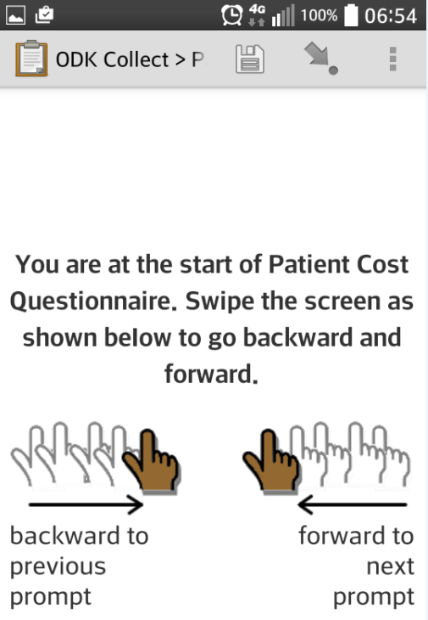 Figure 8a. E-survey tool image

Survey supervisor should check all questionnaires at the end of each day, at least during the start of the survey, to ensure errors are promptly identified and corrected. Thereafter supervisors can check data quality periodically. Data entry can be done either by interviewer (if e-survey), but team leader, by supervisor, or by specially recruited data entry clerks. This should be decided by the survey advisory group.

## Translation for migrants

While the survey tool will be available in the local language, in the case of migrants participating in the survey there might be a need to hire a translator from the migrant’s language into the local language.

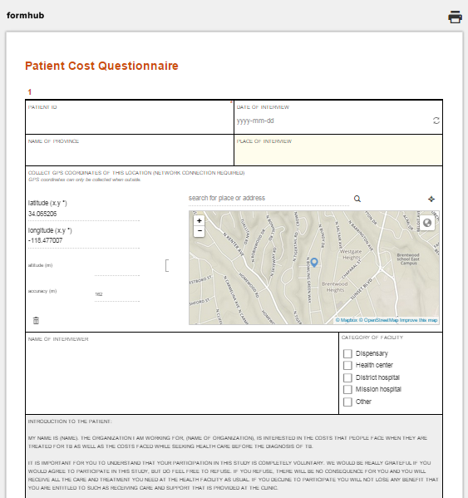

## E-survey

An electronic generic survey system has been set up in WHO Data Coordination Platform (DCP) for secure management of electronic forms and data in real-time between health and development partners ([www.whodcp.org](http://www.whodcp.org)), and the TB patient cost survey described here, has also been uploaded to this system. This platform is part of the [mHero](http://mhero.org) technology suite for effective Ebola response and monitoring (UNMEER). It has also been used for reproductive health. It was chosen mainly because it is open access, allows collecting data offline and uploading online to send to the data repository and may be used for routine data collection in the future if desired. This application allows versioning which means that as the e-patient survey is streamlined following the pilot phase, the data previously collected will not be lost. The WHO Data coordination platform will be available for follow-up and software maintenance. The required technology for the country to use the e-survey is Explorer 8 (or later versions), Mozilla, Chrome, Firefox. To note that the platform does not mean WHO will hold or own the data nor: the country will.

The DCP can be accessed via a computer’s web browser or through ODK (Open Data Kit) Collect, a free Android application. On either platform, the survey will require a network connection for the first occasion it is opened. Once the survey has been loaded one time, users will no longer need an active network connection to access it. If there is an active connection, patient responses will automatically be loaded into a web database. In cases of limited network connection, the form can still be completed and the application/web address will record and save responses internally to be sent to the database when network connectivity is established. On mobile devices, this will require an SD card. Fortunately, these can be purchased cheaply. GTB will assist the end user’s setup of ODK Collect if needed as well as provide technical support throughout data collection.

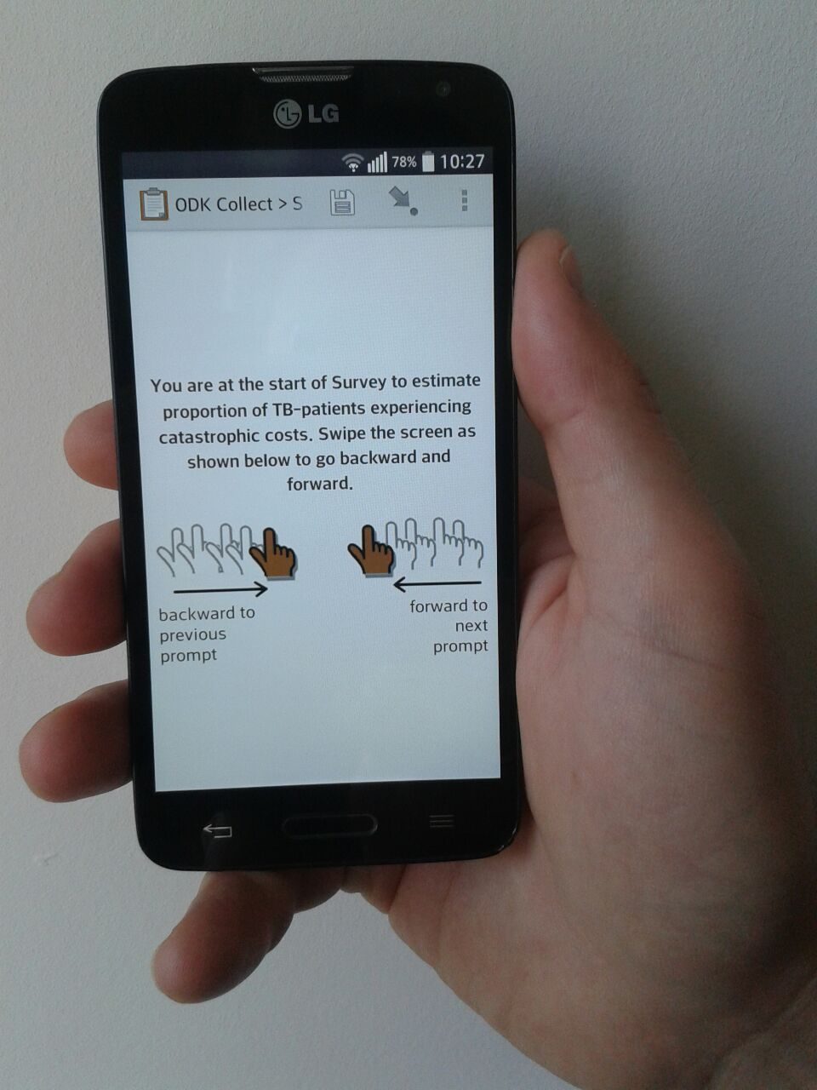

Figure 8b. E-survey tool image on android.

The following link contains an electronic version of the current generic patient cost survey:

**https://cwq6e.enketo.org/webform**

Countries can adapt the questionnaire, translate it and upload it onto this platform, in replacement of the generic protocol. This generic e-survey contains skip patterns and can direct respondents to different sections of the survey according to their type of TB and whether they are interviewed during the intensive or continuation phase. This electronic questionnaire automatically generates key cost calculations. Countries may adapt and change as the generic survey is adapted at country level.

Both local language and English question will appear simultaneously if the e-survey tool is used. If an electronic data entry survey is chosen, an informed consent paper will need to be signed or finger printed by the patient. A photo of the signature or digital print may be added and uploaded to the server and included in the patient survey data.

## 4.7. Manage and enter the data

Data management consists of the processes and procedures for collecting, monitoring, handling, storing, processing, validating and archiving data from the start of the patient survey to its completion. Data transferred from health facility to the NTP and to the designated technical assistance partner, needs to be managed properly to ensure they are accurate and reliable, precise and complete, while always maintaining confidentiality and data integrity.

The generic questionnaire is available both on paper and on a standard electronic questionnaire and data entry form that can be used on androids and laptops.

**Key steps for data management are**:

1. Patient record number, patient name, date of birth and gender are mandatory in the survey (paper or electronic). They are essential for the validation of records by the team that carries out the analysis.

2. The choice of software used in this survey (the WHO Data Coordination Platform), has been guided by the expertise of a database developer at WHO. The software package includes a relational database with robust security. Validation and consistency checks can be used in data entry screens for quality control. Data should be entered and checked continuously during data collection.

3. Direct data entry during interviews is done off-line on the e-survey tool, followed by on-line data up load or done on paper and then followed by electronic data entry at central data management unit. If the interview is carried out using a paper-based survey, electronic data entry will be carried out by data entry clerks at a central data management unit or equivalent. Alternatively interviewers may use the WHO Data Coordination Platform (DCP) off-line to directly make data entry during the interview on the computer device (laptop, notebook, personal digital assistant or mobile phone/android) and will be required to periodically connect to the internet to upload the completed patient questionnaires.

4. All essential documents and electronic files pertaining to the patient survey should be securely stored. These are: signed protocol and amendments, information given to survey participants, financial reports of the survey, signed agreements between involved parties, for example between investigator(s) and sponsoring agency or contracted research organisations, including access to data, reports and publications; dated, documented approval or favourable opinion of institutional review board or independent ethics committee. All survey staff handling data (both on paper and electronically) should respect the confidentiality of the information collected.

5. Adapted and translated questionnaires can easily be imported into the electronic survey form. WHO GTB can assist with this step.

6. Supervision of data collection. Supervision of data collection at health facility level should take place as quickly as possible after data collection so that surveyed individuals can still be approached to check any errors or discrepancies.

7. Periodic cleaning and analysis. The Global TB Programme can assist with periodic data cleaning and analysis. Doing so periodically will allow for communications about potential errors in the survey before they are replicated many times over.

In addition to the above, if the optional longitudinal survey design is chosen, each patient will be followed using the unique identifier and patient registration number in the TB register.

The electronic data collection form performs basic calculations and has internal data error checks.

## 4.8. Analysis of patient costs

### 4.8.1 Introduction to the section

This section presents the proposed analysis plan which responds to the objectives of the study, while outlining the key methodological challenges. The main focus is on the basic cross-sectional design (i.e. patient interviewed once only). A brief summary of the analytical approach for the longitudinal design is also included.

The first study objective is to document the magnitude and main drivers of patient costs in order to guide policies on cost mitigation. The analysis section describes how to calculate the out-of-pocket medical and non-medical payments as well as an estimation of indirect costs, both before TB treatment starts and during the TB treatment. This disaggregation helps identify broad entry points for interventions to mitigate cost. The protocol does not describe further disaggregated analysis useful for the understanding of which types of costs are most important in a given setting. This involves, for example, disaggregating out-of-pocket payments into payments for medicines, tests, consultation fees etc, and disaggregating out-of-pocket non-medical payments into payments for travel, food, etc. Moreover, associations should be analyzed between costs and patient characteristics (type of TB, socioeconomic position, sex), place and model of care (ambulatory, self-administered, hospital-based etc), type of provider (public, private, NGO, etc), and health seeking before TB diagnosis (health providers utilized, time to diagnosis, etc). Descriptive analyses of the type of social and economic support that patients receive should also be done. Such analyses will help inform policy decisions aimed to reduce costs and access barriers. The detailed analytical approach should correspond to the information needs in a given setting, and this generic protocol therefore does not go into details about the required analytical steps and considerations.

The second survey objective is to determine the percentage of TB patients treated in the NTP network (and their households) in the country who incur catastrophic costs (medical and non-medical out-of-pocket payments and indirect costs) defined in Box.1 and depicted in the formula below.

Where

sample size

is the net out-pocket payments for TB diagnosis and treatment made by TB patient’s household (direct net medical payment for TB treatment)

payments related to the use of TB health services, such as payments for transportation, accommodation or food net of any reimbursements to the individual who made the payments

time loss and income loss incurred by both the TB patient and any escort member net of any welfare payment

household’s annual disposable income, defined explicitly. *Disposable income is income net of taxes.*

, the population of interest, patients treated in NTP network

threshold (20% tentatively selected)

A standardized analytical approach is required in order to allow cross-country comparisons and global monitoring of this key indicator for the End TB Strategy. This section therefore provides detailed instructions on how to calculate the numerator and the denominator for this indicator. As discussed above (and further elaborated below), it is important to note that this indicator is not a subset of, or comparable to, WHO’s indicators of households experiencing catastrophic health *expenditure*, which is a general indicator of the lack of financial protection in the overall population. In contrast to the TB-specific indicator of percentage of TB patients incurring catastrophic costs (direct and indirect), the catastrophic health *expenditure* indicator does not include direct non-medical payments nor indirect costs (time loss or income loss), it does not attempt to attribute the burden of direct medical payment to any specific disease, it is not restricted to payments made to a particular type of provider and it is not restricted to the direct medical expenses of a particular member of the household. It is computed using nationally representative income or expenditure surveys.

During the field testing phase of this protocol, results for two alternative approaches for the measurement of catastrophic costs should be calculated. Validation will support the final choice for the routine implementation of the survey worldwide and will allow streamlining the survey instrument. A description of the two approaches required is presented below.

The unit of analysis is the patient but we consider the economic consequences in the context of the household of the patient in the analysis. The analysis will bear in mind, the number of patients sampled that belong to the same household. Costs are calculated from the patient perspective and ignore costs to the provider (e.g. staff time) and other societal costs with the exception of caregiver time.

Costs should be first analyzed using local currency units as the patients are directly reporting them. All local currency amounts will be converted into 2015 US$ as well as PPP$. To do so we will utilize conversion rates and deflators for the year in question provided by the World Bank.

A data dictionary is provided with the protocol (see the column “variable” in the paper and e-survey instrument). Variable names are pre-assigned to facilitate the use of coding into statistical packages. If GTB provides support for data analysis, it will be conducted in Stata 13 (College Station, TX).

As part of the analytical tools proposed to monitor catastrophic cost within NTP patients at national level, a Stata program set up by the GTB will be disseminated using the indicators from the recommended patient survey. Pre-assigned variable names coding each of the patient’s answers are used in the program.

Participant countries are encouraged to establish a national data repository for patient survey data. It is a long term endeavour that involves planning for various aspects (human resources, management, funding, terms of references, standard operating procedures, confidentiality agreements) and therefore requires resources and commitment.

### 4.8.2 Key methodological challenges for the analysis of costs

The calculation of the percentage of TB-affected patients (and their households) that face costs that are above a certain percentage of annual household income faces three key methodological challenges that need to be addressed.

The first methodological challenge relates to obtaining the **appropriate measure of household income** (required for the denominator). Self-reported income can be unreliable, especially in settings where informal economy dominates. In such a situation it is preferable to use an asset score to determine which income quintile the patient/household belongs to, and apply the average income for that socioeconomic quintile. The asset score approach should be based on questions validated in each respective country. Part V of the survey instrument (question; “Constructing a socio-economic status index with household asset questions”) should be adopted or adapted from national Demographic and Household Survey asset questions, National Household Consumption Survey, Lifestyle Monitoring Data or similar. If a suitable validated asset score for establishing income quintiles is not available, this will have to be developed using (principal) component analysis, preferably in collaboration with the national statistics office. Even if a validated asset score exists in a country, it may be preferably to further refine and simplify the score, especially to try to reduce the number of asset questions to be asked in the survey. (Annex 2)

The second methodological challenge is posed when **estimating patient's productivity loss** that is required to account for the indirect costs in the numerator. Box 2 explains the various approaches used in health economics.

The third methodological challenge relates to the **threshold used to determine if costs incurred by patients are catastrophic or not** for households affected by TB. While WHO and the World Bank have well-established thresholds to determine if health care expenditures are catastrophic or not, there is no established threshold available to determine when the economic burden of TB in patients is defined as "catastrophic". The WHO Global TB Programme's task force proposed tentatively to use a threshold of 20% since this level has been associated with poor clinical outcomes (Wingfield et al, 2014). This threshold will be explored as part of the field testing of the protocol.

**Box 3: Estimating indirect costs and valuing patient’s time: a methodological challenge**

The focus of the current protocol involves valuating the *financial* burden of TB on patients, i.e. direct medical payments as well as non-medical payments such as food and transport, but it also involves valuating the *economic* burden, that is estimating the so-called “indirect costs” which are the productivity or economic costs for an individual or household incurred as a result of being ill or spending time seeking treatment (Barter et al., 2012, Drummond et al., 2007 and Russell, 2004).

Two methodological issues are faced when valuing patient’s time. First, it is difficult to define what patients would have done with this time (paid work, unpaid work, leisure) if they had not spent it staying in or visiting health facilities. In other words, it is the opportunity cost that can be difficult to define (WHO, 2002). The second methodology issue is how the opportunity cost should be valued in monetary terms. There is paucity in terms of the measurement of costs associated with the time lost while being unable to work due to seeking care or being too ill to work (Foster, N. 2015). There are several methods to value time loss and they were developped to analyse the consequences at the macroeconomic level rather than at the household level (microeconomic):

The most common method used is the input-based **Human Capital Approach.** Following this approach, an individual's time (or loss of productive time from treatment and illness) is valued based on their estimated productive output based on their reported income *prior* to being ill (by multiplying the estimated productive time lost due to treatment and illness with the reported income *prior* to being ill). This approach is criticized on equity grounds as the higher the income of a patient, the higher the value of their time and it excludes the value of time loss of those not employed or those working but not paid. Lensberg (2013) suggests using a general average wage rate rather than the patient’s wage in order to compensate for the equity imbalance. Alternative approaches include the **equality of wages method** where time loss is valued equally across individuals by using a proxy such as the minimum wage or the average reported income for the cohort (Mauch et al., 2011 and Sinanovic et al., 2003). A central limitation of the input-based approach is that it assumes that every economically active person is a wage earner, when in reality many individuals or households derive income from small businesses that they own and operate. In addition, studies that use an input-based approach to calculate lost household production are most likely overestimated because they assume that the duration of an individual's absence from work fully corresponds to the market value of those lost days. Such an assumption overlooks the so-called 'coping strategies' used by households to mitigate the adverse circumstances of one of their member's being ill (WHO, 2009). On the other hand, coping stratagies may contribute to the economic burden, for example if important household assets are sold off, children are taken out of school to contriute to household earnings, or loans with high interests are taken, and the negative impact of such “coping” may be long lasting and potentially irreversable.

When analysing time loss from a macroeconomic perspective, WHO recommends wherever possible the use of an **“output-related approach”** is used to value productivity losses (i.e. patient’s time loss) (WHO, 2009). To measure the value of lost market production, it is important to assess the value of the production of the sick person and his/her family compared to the counterfactual of what would have happened in the absence of the illness. This can be achieved via what has been termed the output-related approach (Goldschmidt-Clermont, 1987), which focuses on measurable changes in income or product rather than time inputs. Only a few studies have used this approach to date (Attanayake et al., 2000). A central requirement for estimating the actual (rather than potential) losses in production is the comparison of households with and without the health condition in question, so that it is the net effect that is captured and attributed to the condition in question. In the context of this survey, where we are interested on the impact on the household, this approach would be translated into ascertaining change in income during the TB episode as compared to prior to the TB episode. This approach accounts for the situations when days ill or seeking care do not necessarily translate neatly into days of lost work. To use the WHO recommended approach it is necessary to identify total net losses in income since it is better equipped to isolate only the fraction of market production of a household that is actually (rather than potentially) lost. However, this approach requires that change in income can be determined in the study, which is a challenge especially where an informal labour market dominates.

In the field testing period of the current survey, serveral approaches should be tested and compared in order to avoid over-estimating indirect costs.

### 4.8.3 Estimating costs during the TB episode

### Time horizon for TB episode

The survey aims to capture costs related to the whole TB episode where “TB episode” is defined as the period of time from self-reported onset of TB-related symptoms until the end of the continuation phase of treatment (that is the entire illness).

Where t for previously treated patients or MDR patients

Where t for new TB patients

As mentioned in the methods section, to avoid recall bias, we establish the maximum time horizon at two years (to cover for the MDR treatment duration).

## Total costs of a TB episode

The total cost includes all medical and non-medical out-of-pocket payments (direct cost) and time costs (indirect cost) incurred both by the patient and any guardian or other household member accompanying the patient to a health facility.

The total cost of the whole TB episode is calculated as:

Patients will be interviewed in different phases of the illness episode, and reporting on retrospective expenditures and time loss. As explained and depicted in Part III of the protocol data is collected for the particular episode phase the patient is in. Cost will be predominantly estimated for other phases and estimation will be done using costs calculated for similar patients interviewed in the other phases of illness, matched by type of TB and facility. For example, a new drug-susceptible patient interviewed during their continuation phase will not report all costs they incurred during the intensive phase. This patient would be assigned the average cost of the intensive phase among other similar drug-susceptible patients who were interviewed at that facility during the intensive phase.

The total cost for the TB episode thus includes (as shown graphically in Fig. 4)

1. Medical and non-medical out-of-pocket payments, time loss and dissaving incurred **from onset of TB symptoms to TB treatment** **start (i.e. prior to treatment initiation)**

* If new patient in intensive phase:
  + Reported medical and non-medical out-of-pocket payments for outpatient and inpatient care prior to diagnosis (direct costs)
  + Reported dissaving/coping costs (Part V)
  + Reported time loss. Valued time loss (indirect cost) prior to treatment start may be calculated if the analysis choses the Human Capital approach to value time loss. Various options are possible to select a wage to determine time loss:
    1. wage of the lowest paid unskilled government worker (Cameroon, 2009; WHO/HAI, 2008)
    2. patient’s reported pre-illness wage (or labour income) in survey (WHO, 2002 and Drummond et al, 2007)
    3. average wage rate for all working individuals in the country Lensberg B et al, 2013
    4. individual income estimated from household income itself determined through asset scoring. (Novel option that could be explored).
* If new patient in continuation phase or previously treated:
  + Estimated medical and non-medical out-of-pocket payments for outpatient and inpatient care prior to diagnosis (direct costs)
  + Reported dissaving/coping costs prior to treatment start (Part V)
  + Reported time loss. Valued time loss (indirect cost) prior to treatment start may be calculated if the analysis choses the Human Capital approach to value time loss. Various options are possible to select a wage to determine time loss:
    1. wage of the lowest paid unskilled government worker (Cameroon, 2009; WHO/HAI, 2008)
    2. patient’s reported pre-illness wage (or labour income) in survey (WHO, 2002 and Drummond et al, 2007)
    3. average wage rate for all working individuals in the country Lensberg B et al, 2013
    4. individual income estimated from household income itself determined through asset scoring. (Novel option that could be explored).

Costs incurred **during previous TB episodes** to be examined for previously treated cases only.

To avoid recall bias, detailed information about out-of-pocket payments incurred during previous treatments is not collected from previously treated patients. However Part III collects overview data on duration of previous treatment and number and length of any hospitalizations. The direct information from the patient about their previous TB treatment combined with an extrapolation of their current treatment expenditures will be used to estimate a direct cost for the previous treatment.

1. Cost for TB care and treatment incurred **from (TB/MDR) treatment start and** **during the intensive phase**

* If patient in intensive phase: out-of-pocket payments and time loss are directly reported
* If patient in continuation phase: the cost in the intensive treatment phase will be estimated based on information collected during the continuation phase for the same patient. The mode of therapy (e.g. self-administered or directly observed), and the information collected for patients interviewed in the intensive phase of the two phases will play a critical role in this estimation. If the same patient’s continuation phase cannot be used to estimate the cost of their intensive phase we will use an average cost from other patients in the same facility. Regressions are done on small samples and key cost drivers identified, laying the basis to extrapolation to larger samples. (See annex 1: illustration of estimations).

1. Cost for treatment incurred **during the continuation phase** (TB or MDR)
   * If patient in continuation phase: out-of-pocket payments and time loss are directly reported and calculated (Part V)
   * If patient in intensive phase: costs are estimated using data from patients interviewed in the continuation phase

The costs related to each phase of illness and treatment is calculated, for example as:

Where

is the net out-pocket payments for TB diagnosis and treatment made by each TB patient (direct net medical payment for TB treatment)

net payments related to the use of TB health services, such as payments for transportation, accommodation or food

time loss valued for both the TB patient or escort member net of any welfare payment

Cost should be summed for all health care visit and hospitalizations in each phase of illness. For DOT, visits to pick up drugs and other visits for medical follow up, cost data are collected for the latest visit only. The total cost for each type of visit should then be estimated on the basis of the cost of the last visits multiplied by the frequency of visits to pick up drugs or do medical follow up. In principle each visit cost consists of:

where

*= patient's time loss valued*

*Net = payments minus reimbursements*

*=*

*Coping costs or dissaving= asset sale + loan interest*

Where:

* Coping costs include payments of interests on loans taken and lost income due to selling assets that previously generated income.
* Guardian costs are defined below

## Calculating patient's time loss or cost of productivity loss

This section describes the practical approach to time costs to use in the analysis of this protocol (Table 2). The recommendations are consistent with the recommendations from recent literature (WHO, 2009, Lensberg B. et al 2013, Drummond et al, 2007) but this is an area in development and it will be revised during the implementation phase if need be.

Acknowledging that this is one of the most challenging areas of the analysis, the survey instrument allows for the various methods to be explored and compared around a sensitivity analysis.

**Table 2: Practical approach to time costs to use in this protocol**

|  |  |  |  |
| --- | --- | --- | --- |
| **Patient’s time valuation method** | **Patient’s in formal paid work** | **Other patients** | **Recommended by** |
| Output-based approach | Net effect of income change pre and post TB. | Net effect of income change pre and post TB | Wherever feasible by WHO, 2009 |
| Input-based approach: Human capital approach (resolving the equity imbalance) | Number of hours or days reported related to seeking and receiving care will be multiplied by a general average wage rate for all working individuals in the country | Option 1. Value at zero their time (conservative)  Option 2. Value according to average wage of those patients who were in paid work  Option 3. Value according to the average income pre-illness of those patients in the same income quintile. Positioning of the patient within a quintile is possible thanks to the asset ownership and SES questions within the survey.  In addition to previous options. A sensitivity analysis that excludes consideration of time lost altogether (equivalent to valuing everyone’s time at zero) should be done commenting on the difference that this makes to the conclusions to be drawn from the analysis. | Use of general average wage rate is recommended by Lensberg B et al, 2013 |
| Input-based approach: Human capital approach (not resolving equity imbalance) | Number of hours or days reported related to seeking and receiving care will be multiplied by patient’s reported income prior to illness (in survey) | Same as above | WHO, 2002 and Drummond et al, 2007 |

**Table 3.** **Data availability in the survey to value patient’s time according to the method**

|  |  |  |  |
| --- | --- | --- | --- |
| **Patient’s time valuation method** | **Data required** | **Available in** | **Recommendation** |
| Output-based approach | 1. Income pre TB episode 2. Income post TB episode 3. Income loss due to TB | a) Reported income in survey  b) Reported income in survey  c) Calculated based on reported a) and b)  If using this approach, data in the survey allows **calculating indirect costs for the whole TB episode** not through the phases (pre-treatment, intensive, continuation phase) | Where feasible but mostly for macroeconomic analysis purposes, WHO (2009) recommended approach to calculate productivity losses. |
| Human Capital Approach (resolved equity imbalance) | 1. Number of hours lost by the patient 2. Average wage rate for all working individuals in the country . | a) Reported time loss in the various phases of the TB episode  b) National data  If using this approach, data in the survey **allows calculating indirect costs by treatment phase** (pre-treatment, intensive, continuation phase) | This approach, along with input-based approaches is not the preferred WHO (2009) approach but it allows estimating indirect costs in the various phases of the TB treatment episode. Lensberg (2013) recommends this approach.  Lensberg (2013) recommends using average general wage.  WHO-GTB suggest using:  a) Reported wages  b) Estimated individual income based on estimated household income itself determined through asset scoring.  Sensitivity analysis should be performed in particular when patients interviewed are not active in the formal labour market. |
| Human Capital Approach (unresolved equity imbalance) | 1. Number of hours lost by the patient 2. Average reported wage rate | a) Reported time loss in the various phases of the TB episode  b) Reported annual wage in survey  If using this approach, data in the survey **allows calculating indirect costs by treatment phase** (pre-treatment, intensive, continuation phase) | This approach, along with other input-based approaches, is not recommended by WHO (2009) but it allows estimating indirect costs in the various phases of the TB treatment episode. Drummond et al (2007) recommended this approach.  Sensitivity analysis should be performed in particular when patients interviewed are not active in the formal labour market. |

As shown on Table 3. The cost of patient's productivity loss will be calculated as follow (methods are ordered according to WHO recommendations).

a) Using the output-related approach. This implies valuating time loss based on the net effect of reported income change pre and post TB (WHO, 2009).

This recommended approach relies however on individual income before and during TB treatment being collected with reasonable reliability (such as in settings where formal economy dominates). Using this approach implies **calculating indirect costs for the whole TB episode** not through the phases (pre-treatment, intensive, continuation phase)

Where

time loss valued for both the TB patient or any escort member net of any welfare payment

individual income loss (TB patient and any escort member) net of welfare payment

individual (labour) income (of TB patient and any escort member) reported monthly before TB illness

TB illness duration in months

b) Using the Human Capital Approach

* Adjusting for equity considerations:

The number of hours or days reported related to seeking and receiving care will be multiplied by either

b.1) an estimate of the individual income. As the preferred measure of income is household income estimated based on asset scoring, the estimate of individual labour income will be derived from that indicator.

b.2) a general average wage rate for all working individuals in the country (Lensberg, 2013).

b.3) Valuing patients' time that are not employed at a wage of zero or at a mid-point between 0 and the general wage average.

b.4) Valuing patient's time at a wage associated with the income quintile that household asset scoring helped estimate.

A sensitivity analysis may be run to explore the above options.

* Not adjusting, i.e. using reported wage rates.

++ +

Where

Time spent per visit including waiting time

Hospitalisation duration

Travel time

Time employed to pick up drugs

may be either a) zero, b) wage of the lowest paid unskilled government worker (Cameroon, 2009; WHO/HAI, 2008), c)patient’s reported pre-illness wage (or labour income) in survey (WHO, 2002 and Drummond et al, 2007), d)average wage rate for all working individuals in the country Lensberg B et al, 2013 or e) individual income estimated from household income itself determined through asset scoring. (Novel option that could be explored).

## Coping costs

Coping events such as taking a loan or selling assets are thought to be significant enough to be remembered by the patient and hence collected for all patients regardless of which phase of the TB episode they are interviewed in (part V). Reported interest rates and foregone income due to selling income-generating assets will be summed for the whole illness episode (but not beyond the time of recorded or estimated treatment completion, e.g. if a patient is interviewed at week 2 of intensive phase, it is assumed that they will keep their loan until the end of treatment).

## Guardian/companion costs

Guardian/companion costs are included in this survey. They will be calculated as the direct non-medical expenditures of a guardian (or other person accompanying the patient) plus their time loss cost.

*= +*

Where

Guardian cost

*= guardian's time loss valued*

The latter portion will use the same approach to value time as proposed for the patient's time loss. For all patients, direct non-medical costs for guardian costs (transport, food, and accommodation) are included. If the patient is aged under 15 years, all non-medical direct and indirect costs questions concern the guardian.

## 4.8.4. Estimating household annual income before the TB illness episode

The survey instrument (part V) allows computing annual household income before the TB episode through:

1. self-reported disposable individual income (where disposable refers to net of tax)
2. self-reported disposable household income
3. estimated household income on the basis of:
   1. the average net (of tax) wage rate (based on national income data)
   2. asset scoring

An example of how to estimate annual income based on asset scoring is provided in Annex 2. Some useful references are Ferguson B. D et al, 2003, Harttgen K and Vollmer S., 2013. and Seema Vyas et al, 2006.

## 4.8.5. Determining percentage of households experiencing economic burden or catastrophic costs.

Consensus on a tentative measurement of the economic burden incurred by TB patients was reached last March 2015, however it is subject to refinement based on pilot testing. Therefore for the pilot testing phase, the Global TB Programme recommends using the following two approaches.

Approach 1 – calculation of total episode cost as percentage of annual disposable household income before the TB episode – this method has been used successfully in recent studies (Tanimura et al, 2014). It can use either self-reported income or income derived through asset score-based assignment.

Approach 2 – enumerating proportion experiencing dissaving – is a potential proxy indicator of catastrophic cost that requires further validation. Two approaches will be assessed in the field testing.

### Approach 1: calculate the total episode cost as percentage of annual household income before the TB episode.

The first approach is to calculate the total episode cost as percentage of annual household income before the TB episode:

Where

TB episode cost (one or multiple patients per household) net of transfers and reimbursements

Annual household disposable income, defined explicitly. *Disposable income is income net of taxes.*

threshold (20% tentatively selected)

is calculated based on individually reported and estimated medical, non-medical out-of-pocket spending and estimated indirect cost net of transfers and reimbursements. Multiple patients per household will result in direct and indirect costs added.

Annual household income before the TB episode is based either on self-reported income or on an estimate based on household asset scoring.

A dichotomous variable should be created for catastrophic costs occurrence using the following thresholds:

* then costs are “catastrophic” for the patient’s household. This threshold is based on Wingfield et al, 2014.
* (sensitivity analysis)

Other data-driven cut-offs may be defined in a given setting, depending on association with clinical outcomes; with dissaving strategies or other measures of impoverishment.

Each patient (household) will be given a binary (Yes/No) value for whether or not they incurred catastrophic costs due to their TB disease, as defined by the chosen percentage cutoff. These binary values will allow for a calculation of the percentage of TB respondents who incurred catastrophic costs for each country. These percentages may also be reported by income quintile, sex, type of TB, clinic and geographical cluster within countries, if sample size allows.

### Approach 2. Percentage of households experiencing “dissaving”

This is an alternative approach to the “Approach 1”. It calculates the percentage of households experiencing “dissaving” (such as taking a loan or selling property or livestock).

Where

sample size

, the population of interest, patients treated in NTP network

household experiencing dissaving, i.e. asset sale or paying a loan

This proxy indicator may be easier to measure than the first approach, and by definition indicates financial weakening of a household. Occurrence of dissaving has been associated with total costs of TB (Madan et al 2015). However, further work is needed to assess the correlation between high total cost due to TB illness in relation to income and seemingly irreversible coping strategies. The present study protocol will contribute to the development of this proxy indicator. WHO may adapt an operational definition of catastrophic cost based on information on dissaving.

Patients often borrow, use their accumulated savings, and sell financial assets to cope with high costs. The term ‘dissaving’, highlights the fact that it involves reducing the financial strength of a household, in contrast to how savings increases a household’s resilience to financial shocks (Madan J., 2015). Holding assets is an important mechanism for saving in low income households, which often do not have access to any type of financial institution, formal or informal. Potentially, dissaving can be measured much more simply than cost in relation to expenditure and income. It is likely to be associated with financial hardship, and may be a useful proxy indicator for catastrophic cost.

Using data from Part V “Coping costs”, the frequency at which patients had to resort to dissaving, borrowing, or selling assets to cope with TB-related expenses should be established. The percentage of patients that report any of these activities should be reported as well as the average dollar amount of these activities. Using a threshold for the amount of dissaving will be explored although there are several approaches to consider beyond a simple percentage.

Where

sample size

the population of interest, patients treated in NTP network

household experiencing dissaving, i.e. asset sale or paying a loan

threshold (?) *To be determined through operational research*

It should be explored if using an indicator based on the amount of dissaving is giving better precision. Another possible approach could be to assess the presence and/or amount of ‘distressed dissaving’ i.e. sale of income generating assets, through question 122; “The assets that you sold, were they previously supporting the family income (or expenditure)? If yes indicate monthly income previously generated by the assets”.

Taking a loan or selling household items, property, or livestock are not the only adverse coping mechanisms to consider when measuring economic impact of TB on a household. For example, children may be forced to leave school in order to work and support the family of a sick individual. This action could mitigate poverty impacts in the short-term but is likely to have long-term economic consequences for the household. Such events should be reported as additional indicators of financial and social hardship due to TB.

The validation of dissaving as a potential proxy indicator for catastrophic cost is not described in this protocol, and will be covered elsewhere.

## Longitudinal design

The analysis of data from a longitudinal design should follow the same principles as outlines above. With this design, no imputations for estimating costs in various phases of the episode will be required since data will be collected concerning the entire illness episode for each patient through repeat interviews, at least at the start of the treatment and at the end of the treatment. The exception is for cost for previous treatments for previously treated cases, for which standard costs for whole treatments and/or hospitalizations still needs to be imputed.

We suggest for those embarking in the optional longitudinal survey design to repeat questions on dissaving (and even add additional dissaving questions) on the subsequent interviews, in order to help WHO and partners validate “dissaving” as a proxy for “experiencing catastrophic costs”. It is likely that dissaving increases cumulatively, and perhaps the operational solution for periodic surveys would be to only ask about dissaving at the end of treatment (though that would miss defaulters who default due to financial constraints), or at 2 months and at the end (and then no other questions). This topic requires further discussion as results are analyzed.

## Non-response analysis

Using data from part II, it will be possible to compare those patients who agreed to participate with those who declined to do so. A table describing the frequencies of age, sex, type of TB, and HIV status by participation status can be produced. This table should also show the results of t-tests to see if any of these factors differ significantly by participation status. Any large discrepancies between the two groups would harm the external validity of any estimates produced.

### Assessment of differences between sub-populations

Assessment of differences between sub-populations can be performed, depending on sample size. Cross-tabulations of catastrophic cost experience can be produced by income quintile, age, sex, type of TB status, insurance status, etc. Furthermore, a multivariable logistic regression may be run to determine which factors are most significantly associated with an individual TB patient experiencing catastrophic costs. These analyses could shed light on where NTPs, funding agencies, or national governments may be able to reduce direct and indirect costs by changing health care payments/reimbursements, health care delivery modalities, or provision of social protection to mitigate costs for TB patients most efficiently.

## 4.9 Implementation and dissemination plan

## Plan for dissemination and publication of the project findings

Data collection using the task force recommended method, will be initiated in at least 5 countries in 2015 and at least 10 countries in 2016 according to methods agreed in at the Task Force meeting (March 2015 meeting)

## Timeline for dissemination

By September 2016, at least 3 countries (embarking in the Q3 2015 on the survey) should be ready to disseminate results.

Principal investigators will take the lead in publication and dissemination of results in the scientific media, but also to the community and/ or the participants, and consider dissemination to the policy makers where relevant.

Table 2. Suggested timeline for a country starting in 2015

|  |  |  |  |  |  |  |  |  |  |  |  |  |  |
| --- | --- | --- | --- | --- | --- | --- | --- | --- | --- | --- | --- | --- | --- |
|  | **2015** | | | | **2016** | | | | | | | |  |
| **S** | **O** | **N** | **D** | **E** | **F** | **M** | **A** | **M** | **J** | **J** | **A** | **S** |
| **Adaptation of the generic protocol and questionnaire** |  |  |  |  |  |  |  |  |  |  |  |  |  |
| **Ethics Committee Submission** |  |  |  |  |  |  |  |  |  |  |  |  |  |
| **SOP Writing** |  |  |  |  |  |  |  |  |  |  |  |  |  |
| **Translation of questionnaire into local language** |  |  |  |  |  |  |  |  |  |  |  |  |  |
| **Electronic survey adaptation** |  |  |  |  |  |  |  |  |  |  |  |  |  |
| **Kick Off Meeting** |  |  |  |  |  |  |  |  |  |  |  |  |  |
| **Data Collection** |  |  |  |  |  |  |  |  |  |  |  |  |  |
| **a) Patient Recruitment** |  |  |  |  |  |  |  |  |  |  |  |  |  |
| **b) Site Supervision Visits** |  |  |  |  |  |  |  |  |  |  |  |  |  |
| **Analytical Plans** |  |  |  |  |  |  |  |  |  |  |  |  |  |
| **Activity Report to funder** |  |  |  |  |  |  |  |  |  |  |  |  |  |
| **Data Cleaning / Analysis** |  |  |  |  |  |  |  |  |  |  |  |  |  |
| **Final Report** |  |  |  |  |  |  |  |  |  |  |  |  |  |
| **Dissemination of Results** |  |  |  |  |  |  |  |  |  |  |  |  |  |

## 4.11. Budget

Total budget required for this survey probably ranges from US$ 10.000 to US50.000 depending on ambition level and amount of external support needed. Major factors that influence the amounts of funding required for the survey are sample size and staff costs. The number of clusters and sample size affect the number of survey teams.

**The typical components of a budget for a patient cost survey are:**

* Staff salaries or incentives and insurance
* Technical assistance
* Computer equipment, supplies and maintenance (including android phones and tablets purchased)
* Mobile Air-time for interviewers
* Training (incl. fees and per diems)
* Survey documentation
* Meetings and workshops
* Ethical Review
* Pre-visit to each cluster
* Contingency
* Patient incentives
* Analysis of data and preparation of survey report
* Final review and agreement of results
* Workshop
* Publication in scientific journal

Table 3. Example of budget template to establish budget for the patient cost survey



# References

1. Attanayake N, Foxotecting Households from Catastrophic Health Spending,” Health Affairs 26, no. 4 (2007): 972–983er*Tropical Medicine & International Health.* 2000;5(9):595-606.
2. Barter DM, Agboola SO, Murray MB, Bärnighausen T. Tuberculosis and poverty: the contribution of patient costs in sub-Saharan Africa–a systematic review. *BMC Public Health.* 2012;12(1):980.
3. Cameron A, Ewen M, Ross-Degnan D, Ball D, Laing R. Medicine prices, availability, and affordability in 36 developing and middle-income countries: a secondary analysis. Lancet 2009;373:240–9.
4. Drummond MF. *Methods for the economic evaluation of health care programmes.* Oxford university press; 2005.
5. Floyd K. Guidelines for cost and cost-effectiveness analysis of tuberculosis control. *World Health Organisation.* 2002.
6. Foster N, Vassall A, Cleary S, Cunnama L, Churchyard G, Sinanovic E. The economic burden of TB diagnosis and treatment in South Africa. *Social Science & Medicine.* 2015;130:42-50.
7. Goldschmidt Clermont L. *Economic evaluations of unpaid household work: Africa, Asia, Latin America and Oceania.* 1987.
8. Goudge J, Russell S, Gilson L, Molyneux C, Hanson K. Household experiences of illllia.en of TB diagnosis and mechanisms. *Journal of International Development.* 2009;21(2):159-168.
9. Harttgen K, Vollmer S. Using an asset index to simulate household income. *Economics Letters.* 2013;121(2):257-262.
10. Hoa N, Tiemersma E, Sy D, et al. Household expenditure and tuberculosis prevalence in VietNam: prediction by a set of household indicators. *The International Journal of Tuberculosis and Lung Disease.* 2011;15(1):32-37.
11. KNCV Tuberculosis Foundation. Tool to Estimate Patients’ Costs. 2009.
12. Laurence YV, Griffiths UK, Vassall A. Costs to Health Services and the Patient of Treating Tuberculosis: A Systematic Literature Review. *PharmacoEconomics.* 2015:1-17.
13. Lensberg BR, Drummond MF, Danchenko N, Despiégel N, François C. Challenges in measuring and valuing productivity costs, and their relevance in mood disorders. *ClinicoEconomics and outcomes research: CEOR.* 2013;5:565.
14. Lönnroth K, Glaziou P, Weil D, Floyd K, Uplekar M, Raviglione M. Beyond UHC: monitoring health and social protection coverage in the context of tuberculosis care and prevention. 2014.
15. Madan J, Lönnroth K, Laokri S, Squire S. What can dissaving tell us about catastrophic costs? An analysis of the relationship between patient costs and the sale of assets, or uptake of loans, by tuberculosis patients in India, Tanzania and Bangladesh. *(under review).* 2015.
16. Mauch V, Bonsu F, Gyapong M, et al. Free tuberculosis diagnosis and treatment are not enough: patient cost evidence from three continents. *The International Journal of Tuberculosis and Lung Disease.* 2013;17(3):381-387.
17. Murray CJ, Evans D. *Health systems performance assessment.* Office of Health Economics; 2006.
18. O'Donnell OA, Wagstaff A. *Analyzing health equity using household survey data: a guide to techniques and their implementation.* World Bank Publications; 2008.
19. Organization WH. *The World Health Report [2010]: Health Systems Financing; the Path to Universal Coverage.* 2010.
20. Russell S. The economic burden of illness for households in developing countries: a review of studies focusing on malaria, tuberculosis, and human immunodeficiency virus/acquired immunodeficiency syndrome. *The American journal of tropical medicine and hygiene.* 2004;71(2 suppl):147-155.
21. Saksena P, Hsu J, Evans DB. Financial risk protection and universal health coverage: evidence and measurement challenges. 2014.
22. Tanimura T, Jaramillo E, Weil D, Raviglione M, Lönnroth K. Financial burden for tuberculosis patients in low-and middle-income countries: a systematic review. *European Respiratory Journal.* 2014;43(6):1763-1775.
23. Vyas S, Kumaranayake L. Constructing socio-economic status indices: how to use principal components analysis. *Health policy and planning.* 2006;21(6):459-468.
24. Wagstaff A, Doorslaer Ev. Catastrophe and impoverishment in paying for health care: with applications to Vietnam 1993-1998. *Health economics.* 2003;12(11):921-933.
25. Wingfield T, Boccia D, Tovar M, et al. Defining catastrophic costs and comparing their importance for adverse tuberculosis outcome with multi-drug resistance: a prospective cohort study, Peru. 2014.
26. World Health Organization. Health Action International. Measuring Medicine Prices, Availability Affordability and Price Components, 2nd edition; 2008.
27. World Health Organization. WHO guide to identifying the economic consequences of disease and injury. 2009.
28. World Health Organization. *Tuberculosis prevalence surveys: a handbook.* Geneva, Switzerland 2011.
29. 2WHO and World Bank First Global Monitoring Report on Tracking Universal Health Coverage. 2015. <http://www.who.int/healthinfo/universal_health_coverage/report/2015/en/>.
30. WHO Data Coordination Platform (DCP) for Secure management of electronic forms and data in real-time between health and development partners. 2015. https://whodcp.org/.
31. Xu K. Distribution of health payments and catastrophic expenditures Methodology. 2005.
32. Xu K, Evans DB, Carrin G, Aguilar-Rivera AM, Musgrove P, Evans T. Protecting households from catastrophic health spending. *Health affairs.* 2007;26(4):972-983.
33. Xu K, Evans DB, Kawabata K, Zeramdini R, Klavus J, Murray CJ. Household catastrophic health expenditure: a multicountry analysis. *The lancet.* 2003;362(9378):111-117.
34. Yunzhou R. The affordability and acceptability of a new model of universal coverage for multidrug-resistant tuberculosis in China. 2014.

# Acknowledgements

The writing of the main part of the protocol was led by Inés Garcia Baena (WHO) and Knut Lönnroth (WHO) with major contributions from Andrew Siroka (WHO), Charalampos Sismanidis (WHO) and Diana Weil (WHO).

Review and input was provided from the Task Force members, listed below as well as from William Wells (USAID) and Charlotte Colvin (USAID).

It was externally reviewed by Gabriela Flores Pentzke Saint-Germain (WHO), Katherine Floyd (WHO) and Joe Kutzin (WHO).

# Technical assistance

Technical assistance is available from WHO and other international technical partners.

Contact details of core team at WHO:

Global TB Programme | World Health Organization

20, avenue Appia – 1211 Geneva 27 – Switzerland

Knut Lönnroth (PSI): [lonnrothk@who.int](mailto:lonnrothk@who.int) || Tel: +41 22 791 1628

Diana Weil (PSI): [weild@who.int](mailto:weild@who.int)|| Tel: +41 22 791 3072

Andrew Siroka (M&E): [sirokaa@who.int](mailto:sirokaa@who.int)  || skype : asiroka

Ines Garcia Baena (M&E): [garciabaenai@who.int](mailto:garciabaenai@who.int)  || Tel: +41 22 791 4642|| skype : garciabaenaiwhoint

Charalampos Sismanidis (M&E): [sismanidisc@who.int](mailto:sismanidisc@who.int) || Tel: +41 22 791 3513||

# 

# Task force members (including at WHO secretariat)

Bhargava, Anurag D. (Himalayan Institute of Medical Sciences)

Boccia, Delia (London School of Hygiene and Tropical Medicine)

Collins, David (Management Sciences for Health – Cambridge)

Dadu, Andrei (WHO/Euro)

Flores Pentzke Saint-Germain, Gabriela (World Health Organisation, Health Financing Policy)

Garcia Baena Inés (World Health Organisation, Global TB Programme)

Garcia-Basteiro, Dr Alberto L. (Centro de Investigacao em Saude de Manhica)

Hanson, Christy (Macalester College)

Holohan, Meghan (USAID)

Jaramillo Ernesto (World Health Organisation, Global TB Programme)

Laokri, Samia (Global Health Systems and Development)

Lönnroth Knut (World Health Organisation, Global TB Programme)

Menzies, Richard (Mc Gill University)

Mukadi, Ya Diul (Global Health Bureau, USAID)

Pedrazzoli, Debora (London School of Hygiene and Tropical Medicine)

Putoto, Giovanni (Doctors with Africa CUAMM)

Rachow, Andrea (Germany)

Rosen, Sydney (Boston University School of Public Health)

Simpson, Sarah (Equiact)

Siroka Andrew (World Health Organisation, Global TB Programme)

Sismanidis Babis (World Health Organisation, Global TB Programme)

Squire, Stephen B. (Liverpool School of Tropical Medicine)

Sweeney, Sedona (London School of Hygiene and Tropical Medicine)

Tessera, Ezra (The Global Fund)

Thorson, Anna (Karolinska Institutet)

Van den Hof, Susan (KNCV Tuberculosis Foundation)

Vassall, Anna (London School of Hygiene and Tropical Medicine)

Volz (World Health Organisation/PAHO)

Wandwalo, Eliud (The Global Fund)

Weil Diana (World Health Organisation, Global TB Programme)

Wingfield Tom (Global Health Systems and Development)

# Annex 1 Analysis: basic result calculations (mock data)







|  |  |  |  |
| --- | --- | --- | --- |
| **Table 4. Non-Respondents Analysis** | | | |
|  |  |  |  |
| **Patient ID** | Respondents | Non-Respondents | Significant |
| Male (%) | 58 | 56 |  |
| Age (years) | 33 | 38 | ** |
| Pulmonary (%) | 82 | 81 |  |
| MDR-TB (%) | 11 | 10 |  |
| Total duration (months) | 8.4 | 7.1 | * |
| Previously treated (%) | 17 | 6.3 | *** |
| HIV+ (%) | 11 | 10 |  |
| Notes: *p<0.05, ** p<0.01, *** p<0.001. | | | |
|  | | | |

# Annex 2: Estimating income based on asset questions: A Practical Example in Ethiopia

We identified a recent household survey in Ethiopia, the 2013-2014 Ethiopian Socioeconomic Survey, Household Questionnaire that is nationally representative and asks questions on household income, ownership of household assets and dwelling characteristics. Through the World Bank’s Microdata Catalog, we were able to download this dataset and begin the analysis.

The first step was to see which factors are most predictive of disposable (labour) income (i.e. income net of taxes).This step should be undertaken during survey development so that the Patient Cost survey can include several asset questions that are shown to be predictive of income in the country. In this example, these were having 1) a flush toilet, 2) piped water, 3) a mattress, 4) a radio, 5) a cellphone, 6) a wristwatch, and 7) a blanket.

Once the questions are selected, we use a regression equation to show the relationship between these questions and reported household income. A similar method has been used to link assets to household income and expenditure in Vietnam.1 The resulting coefficients of this regression will be used to predict household income for respondents in the Patient Cost Survey. Our prediction equation for Ethiopia is:

where is total income in household *j.*

In our Patient Costs survey, if a respondent has all of these characteristics in their household they would be assigned an annual household income of US$ 663. If they had only a blanket, cell phone, and wristwatch they would be assigned a household income of US$ 201 per year.

1. Hoa NB, Tiemersma EW, Sy DN, et al. Household expenditure and tuberculosis prevalence in VietNam: prediction by a set of household indicators. *Int J Tuberc Lung Dis.* Jan 2011;15(1):32-37.

# Annex 3 Consent form

Introduction to the patient:

My name is (name). The organization I am working for, (name of organization), is interested in the costs that people face when they are treated for TB as well as the costs faced while seeking health care before the diagnosis of TB.

The information that you choose to share will be used for research purposes. It will be shared with other researchers for further analysis and published, but all your personal information will first be deleted in order to ensure full confidentiality.

It is important for you to understand that your participation in this study is completely voluntary. We would be really grateful if you would agree to participate in this study, but do feel free to decline. If you decline, there will be no consequence for you and you will receive all the care and treatment you need at the health facility as usual. If you decline to participate you will not lose any benefit that you are entitled to such as receiving care and support that is provided at the clinic.

If you decide to participate, I would like to stress that you will not receive any reimbursements for the costs that you report on in this interview.

If you choose to participate in this study, you may still withdraw from the study at any stage without giving any explanation for your withdrawal. Your answers will be kept confidential. At some point I will ask you about your personal income and the income of your household. We will NOT provide this information to any tax or welfare authorities, even after the study has been completed.

In charge of this study is the Principal Investigator: (name, address, email). The outcome of this study will be disseminated in an open source journal and you may request a copy from the principal investigator.

**This survey will take approximately 60-90 minutes.**

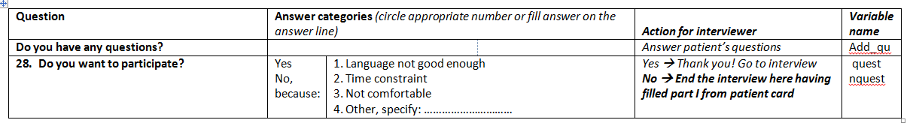

**Patient signature________________________________________________(A duplicate of this signed questionnaire should be offered to the patient)**